1. **Create a project** in Altium:

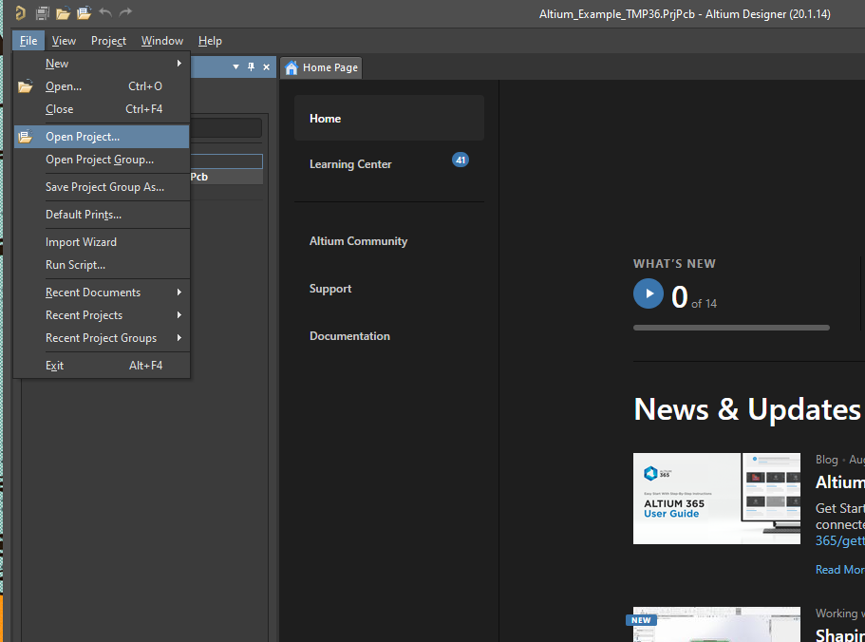

Choose a place for your project:

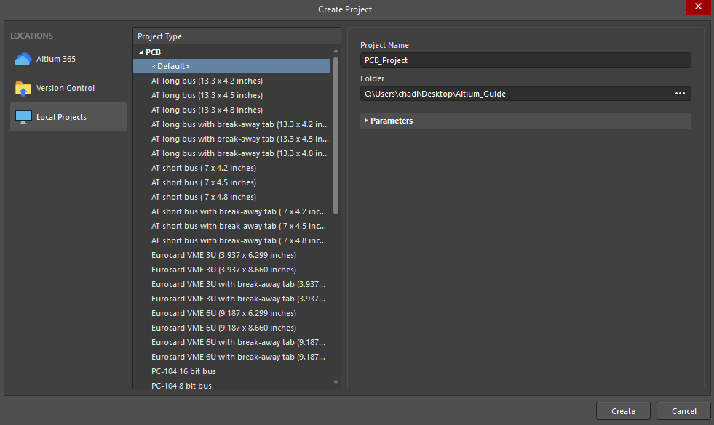

1. **Add schematic file** to project:

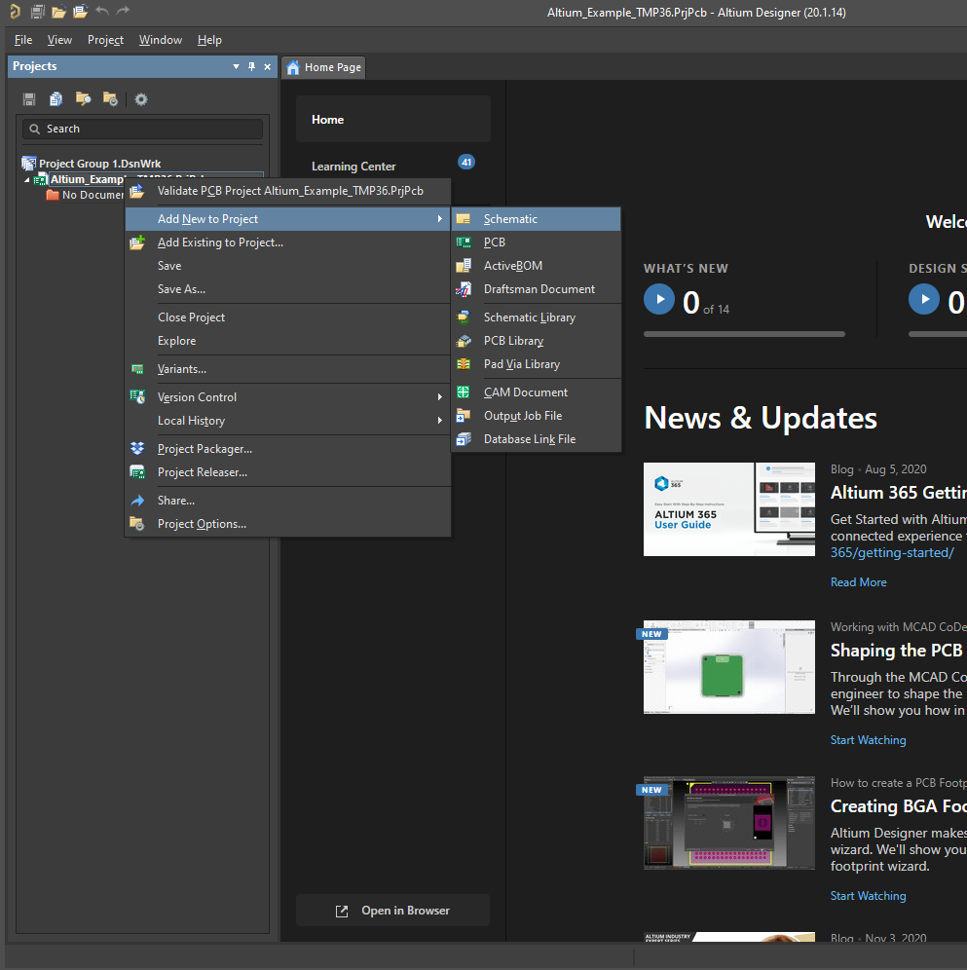

Place part by right clicking the schematic > place > part (or hit “p” key twice)

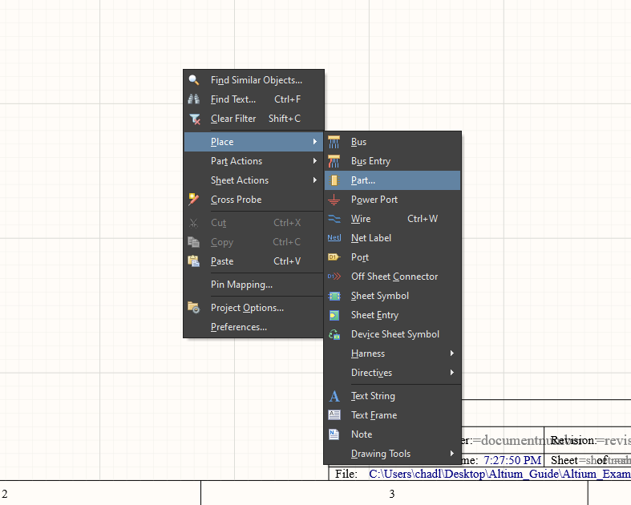

Place Part list: Choose or search for a part:

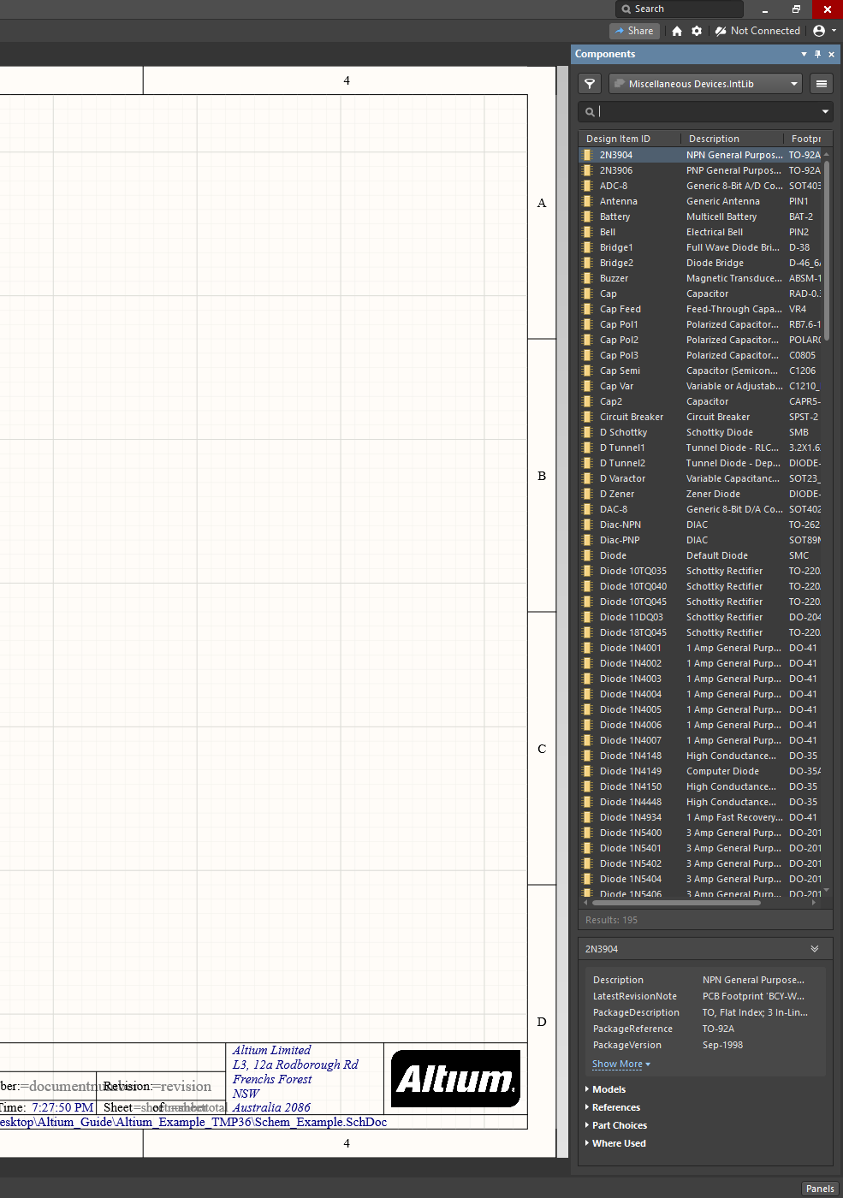

To open Manufacturer part search > click on “Panels” in the bottom right:

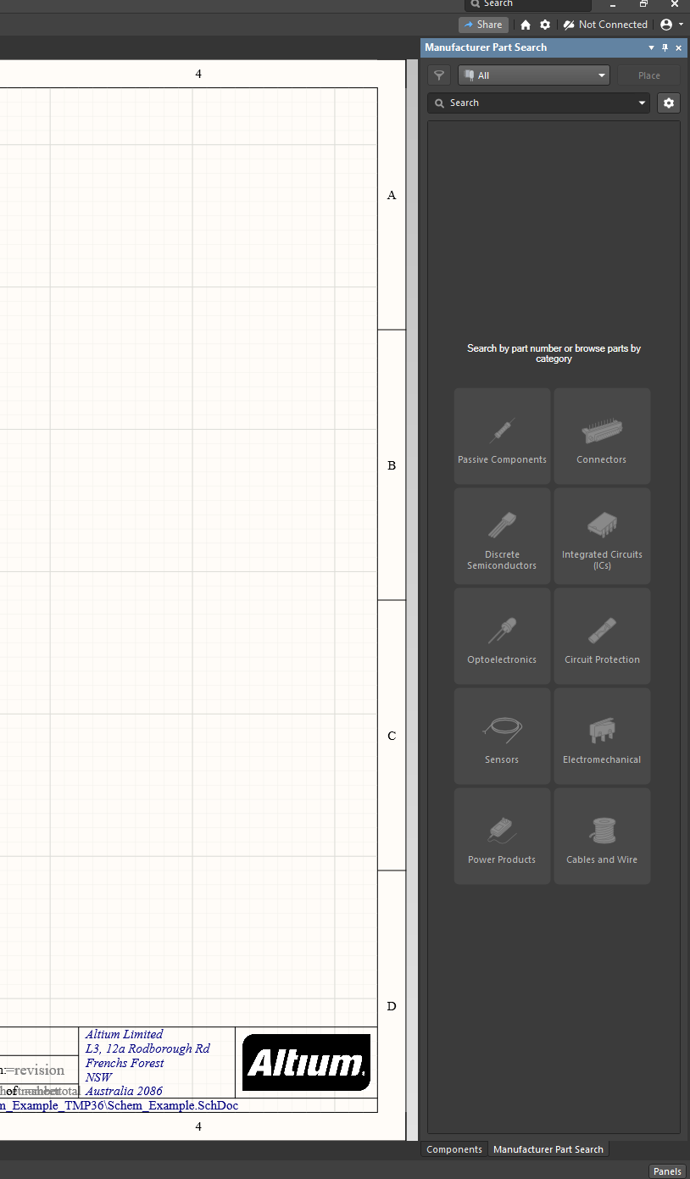

Search for a part:

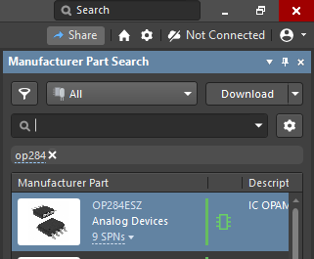

Right click the part and hit “place”:

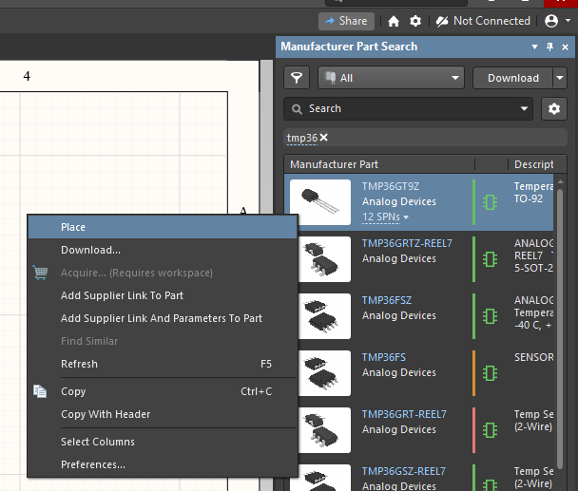

The part will now appear with your cursor in your schematic, click to place the part:

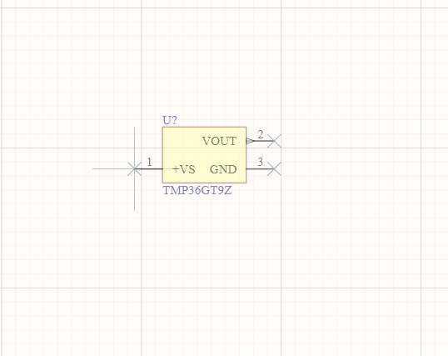

Note that the part is not named yet (U?) but we will deal with this later

Place the other parts you will need:

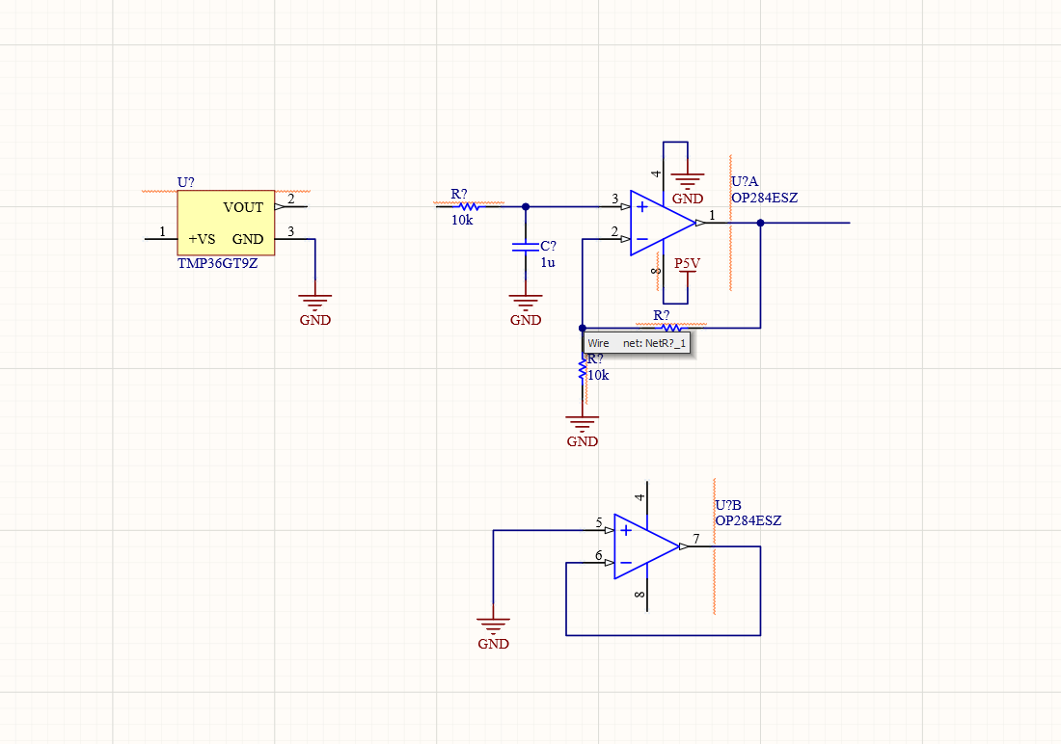

To place wire, right click > place > wire or hit CTRL + W:

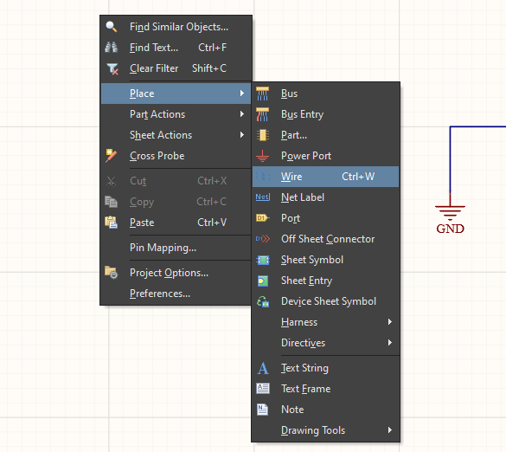

Placing the wire: Click once to “start” a wire” & then move the cursor and click again to “finish” the wire

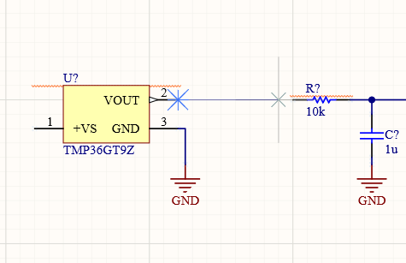

Finished Schematic:

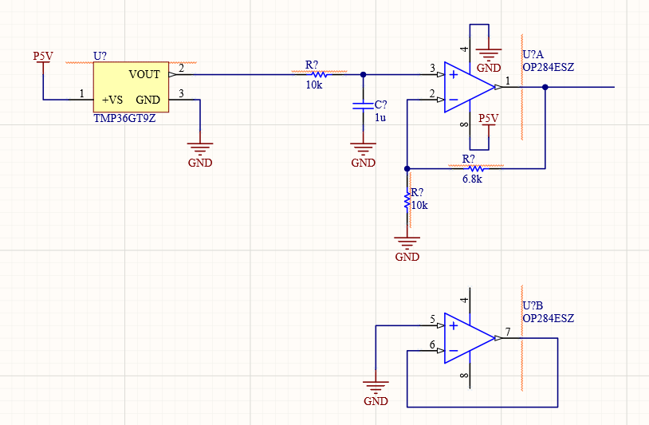

Naming parts on the schematic: (Tools > Annotation > Annotate Schematics Quietly)

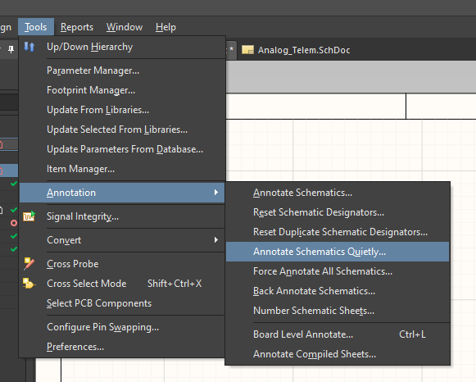

Complete Schematic:

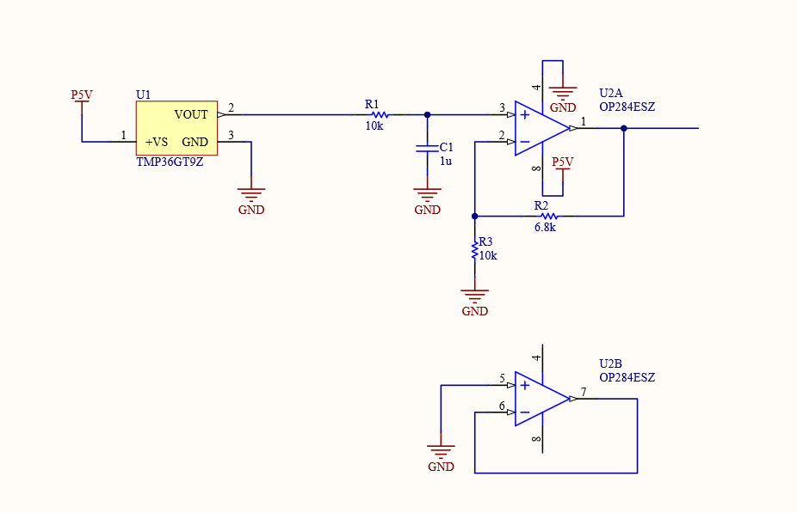

1. **Add PCB file:** (Right click on “Altium_Example_TMP36”)

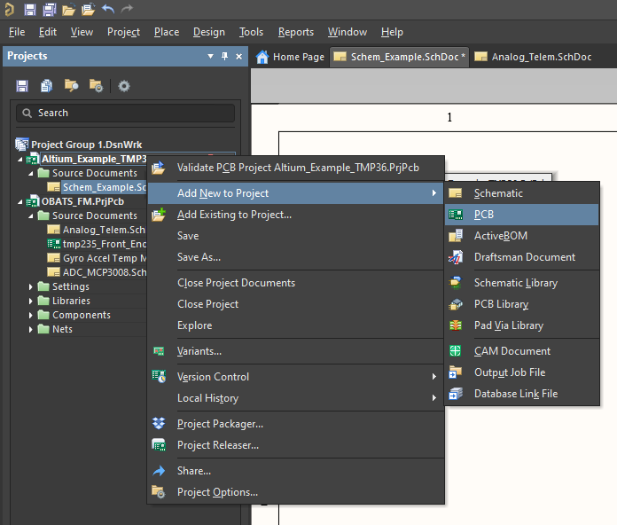

The following will appear:

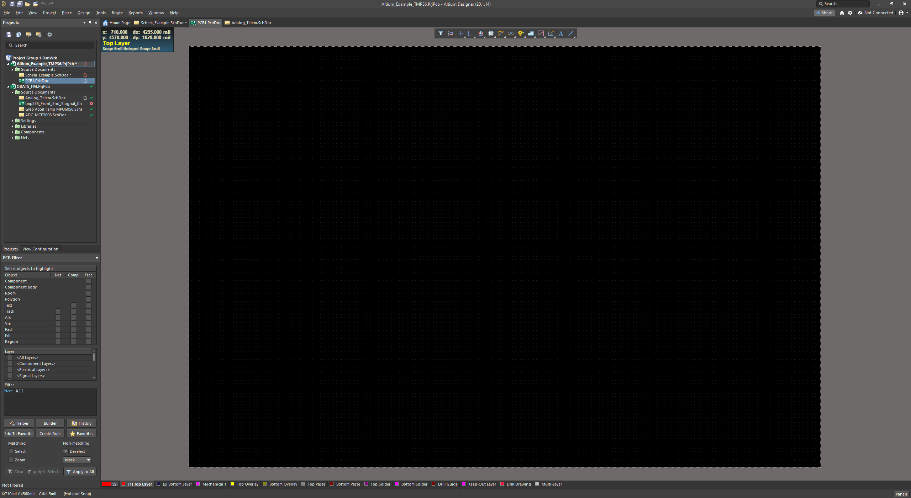

Press 1 to change view:

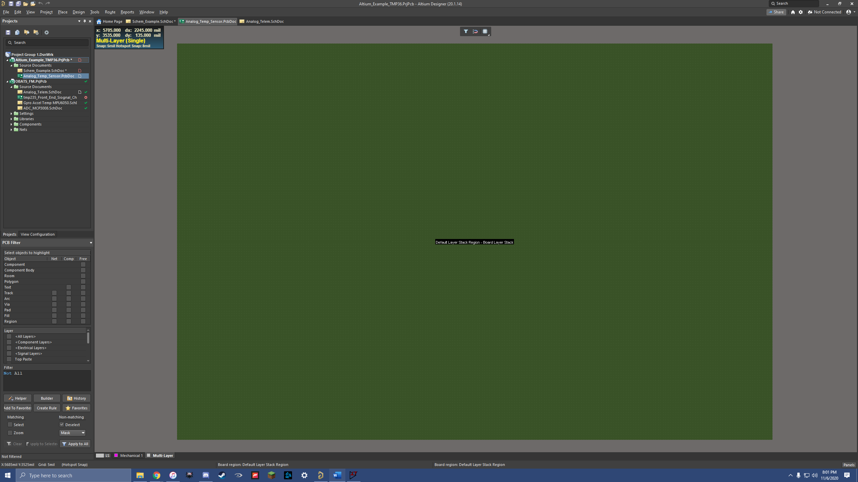

Hit Design > Redefine board shape

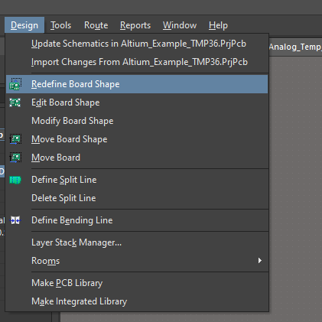

Finished Board:

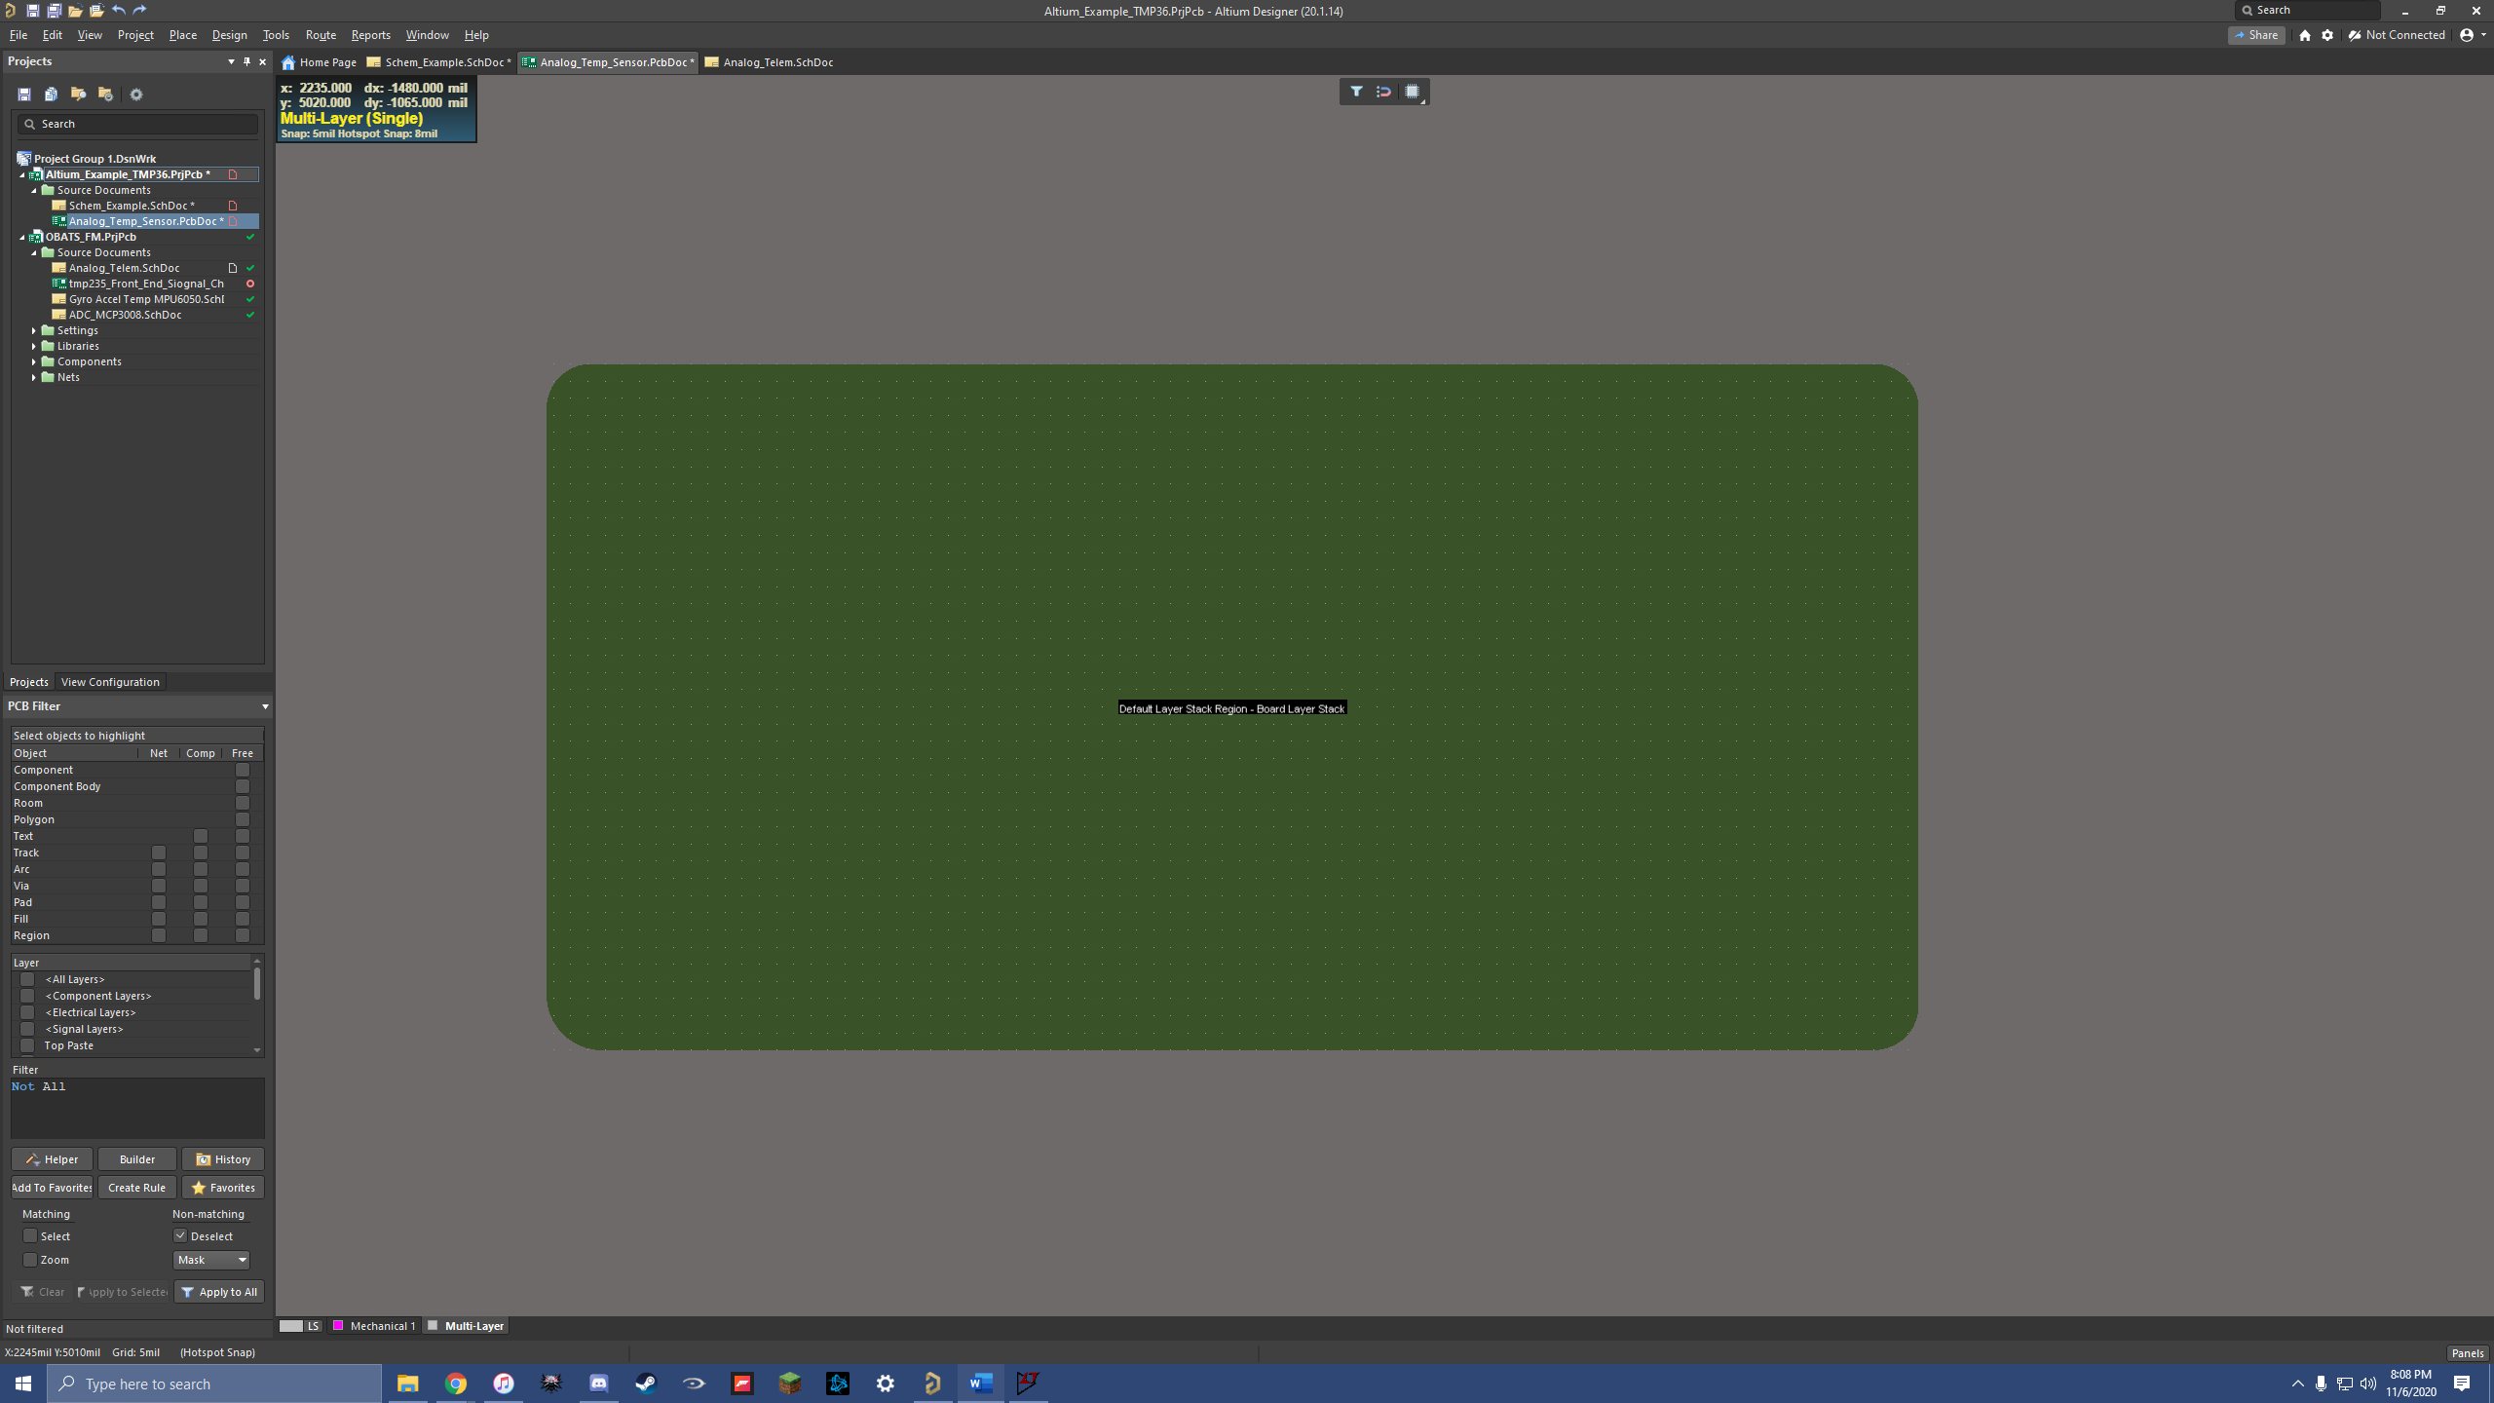

Add Layers to board: (we will do 2 layers for simplicity):

Hit Design > Layer Stack Manager:

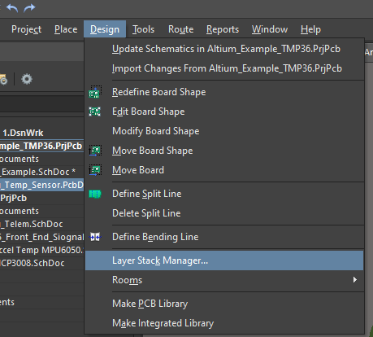

Following page will open:

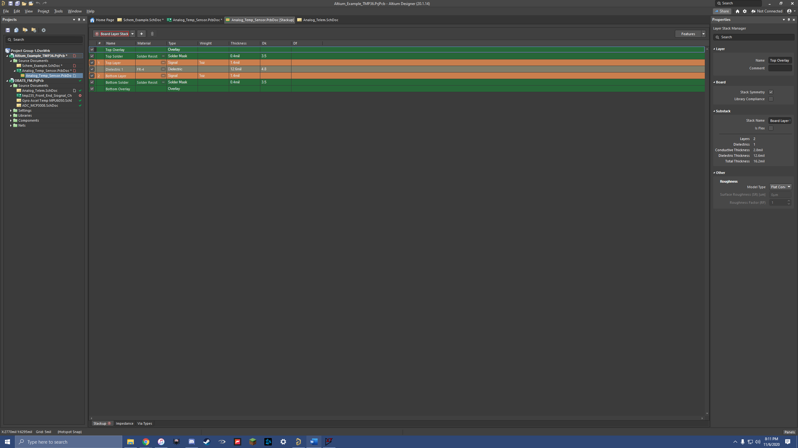

Select Material dimensions for insulators signal layers:

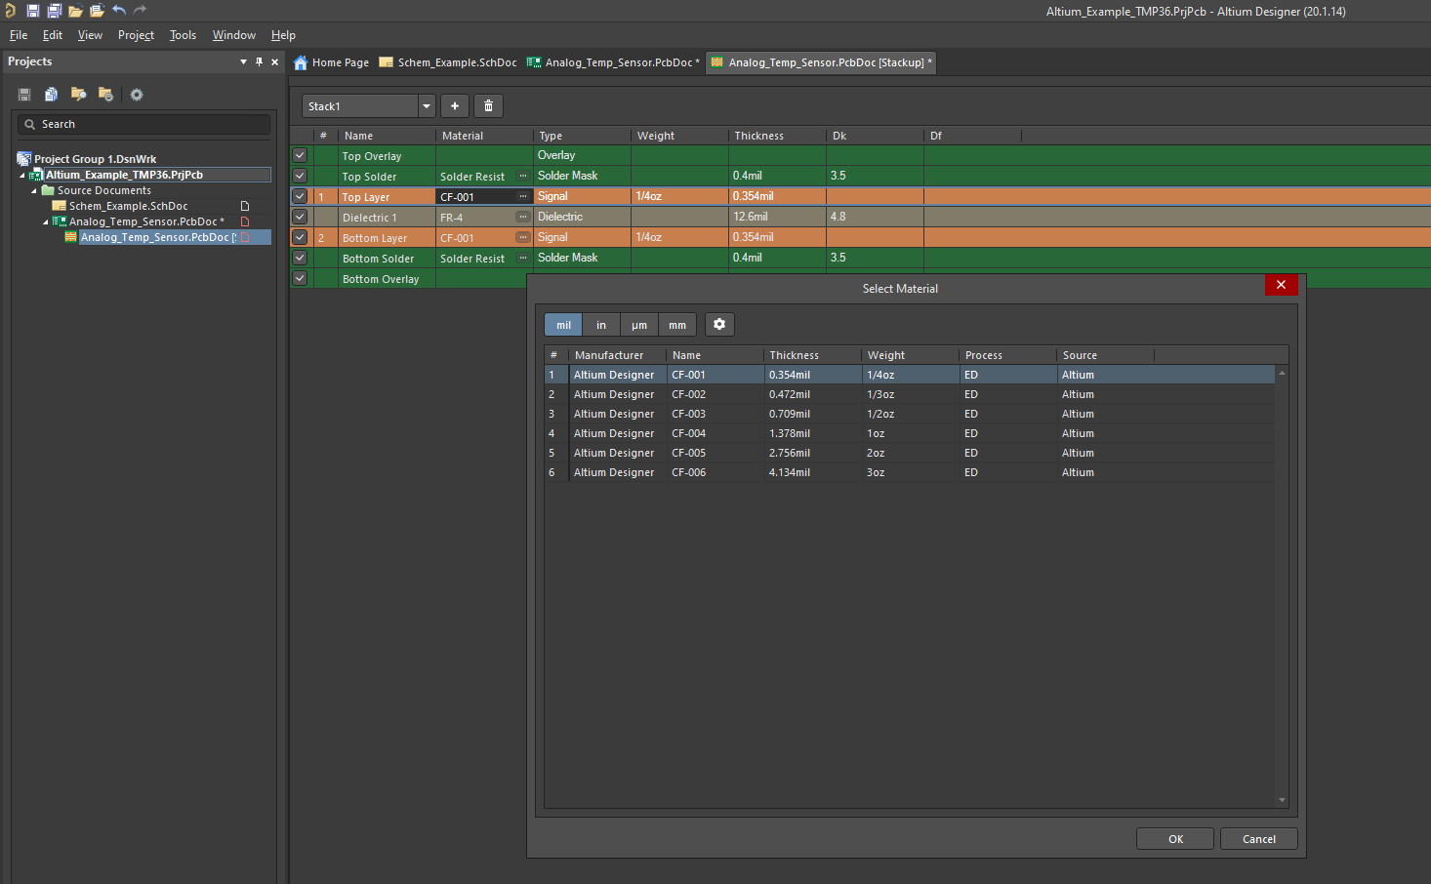

Add a plane layer: (Right click anywhere on layer “1”)

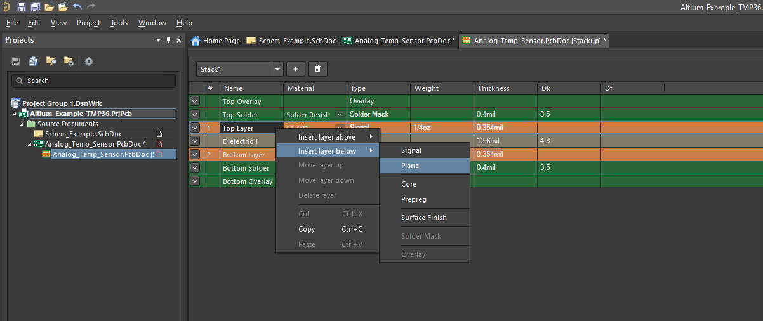

New Layer Stack:

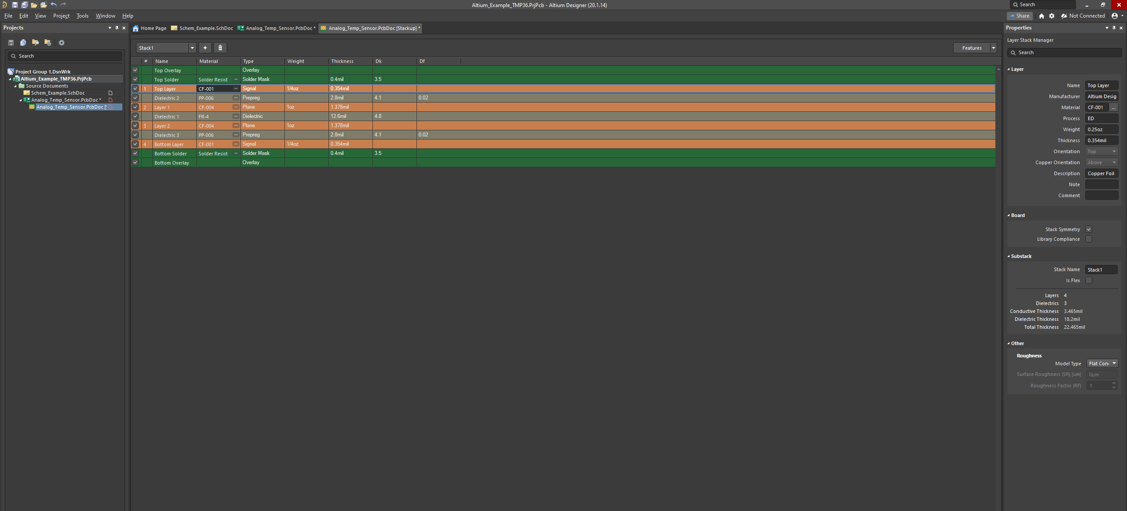

1. **Run (Validate) DRC on Schematic** (Design Rule Check):

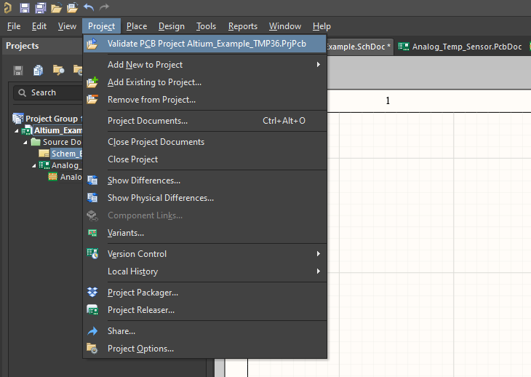

If there is nothing wrong with schematic, nothing will happen

1. **Update PCB Document with Schematic components:**

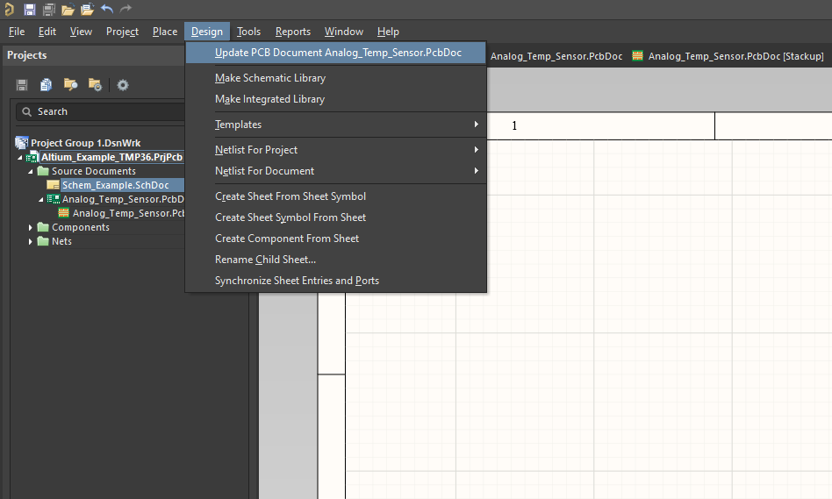

Validate changes before moving to PCB file:

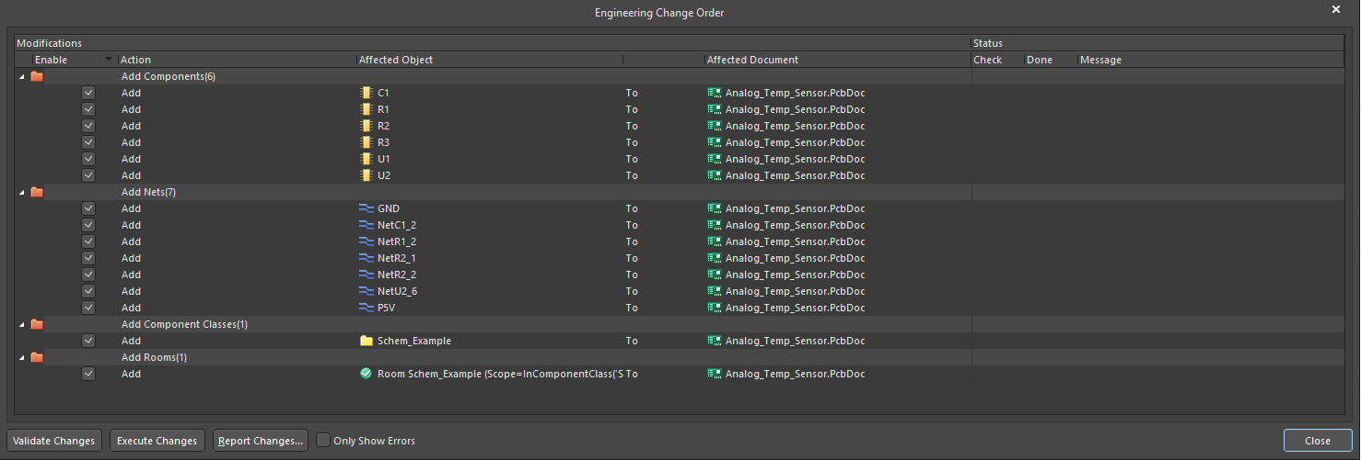

Hit “Validate Changes” and then “Execute Changes”

This should open the PCB document with the schematic components

Hit the “2” key to switch to 2D mode:

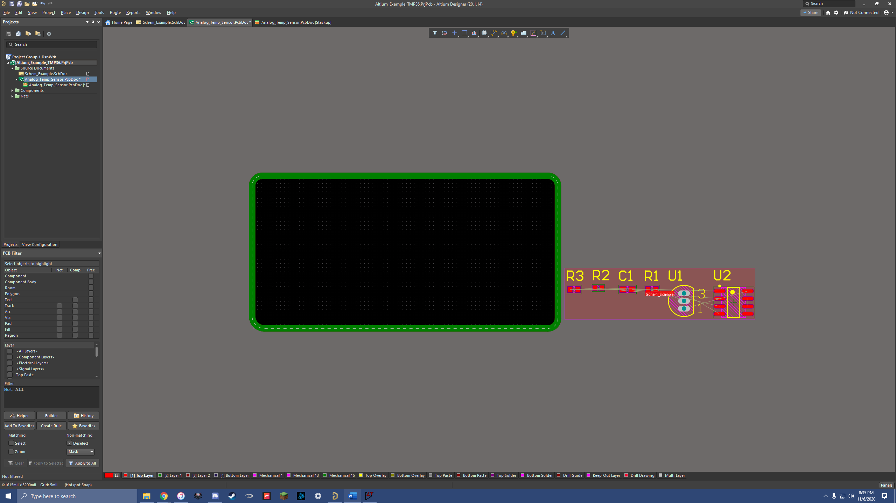

Before we start placing:

The bottom of the screen can be used to select layers of the board:



***While making this portion of the guide, I realized that I forgot to connect power and GND to capacitors and a solder pad

Schematic Parts Added:

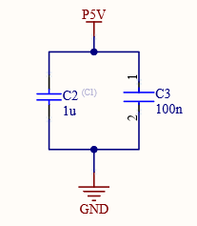

***Make sure to update changes to PCB after editing schematic file

1. **Place Parts Onto PCB**

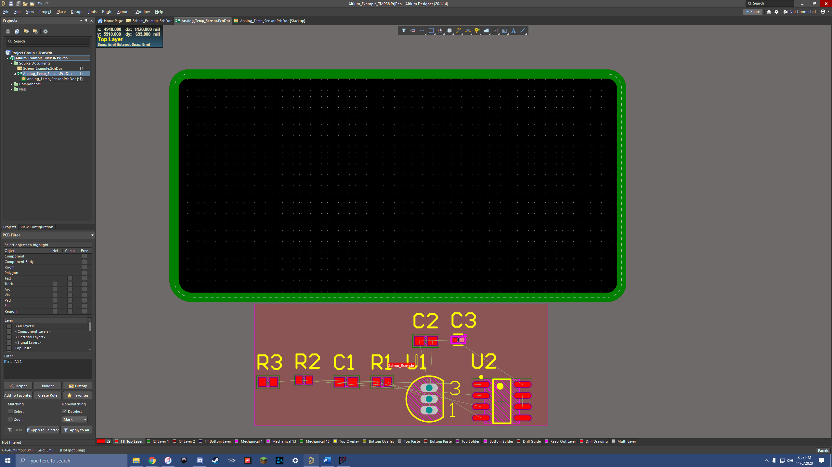

Move Keep out layer along with parts onto board:

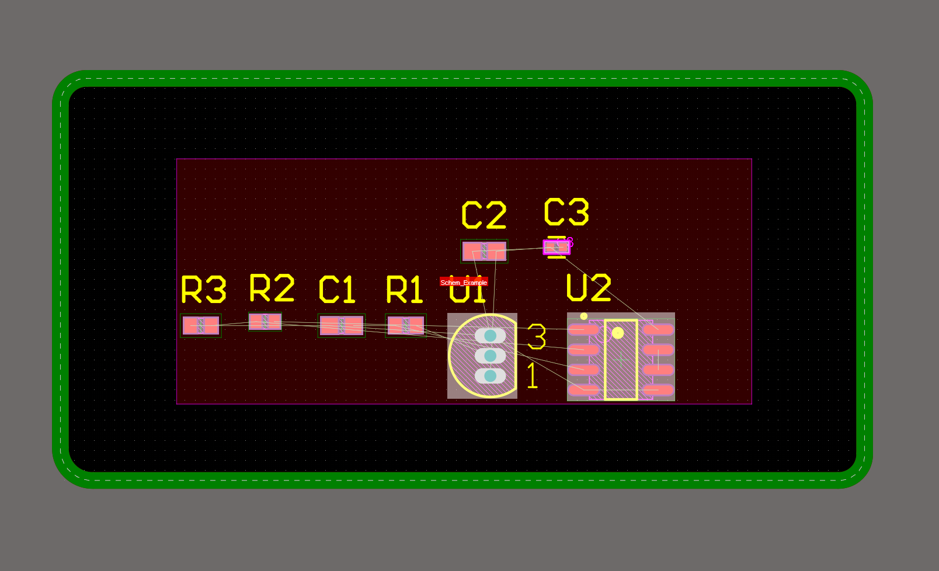

Before moving parts, lets make these giant designators smaller:

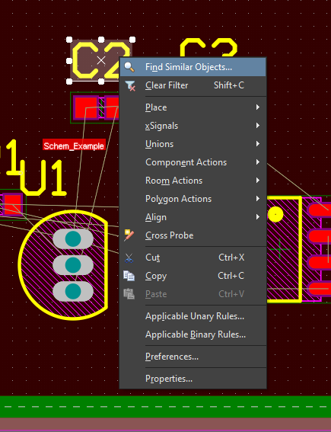

Hit “okay”

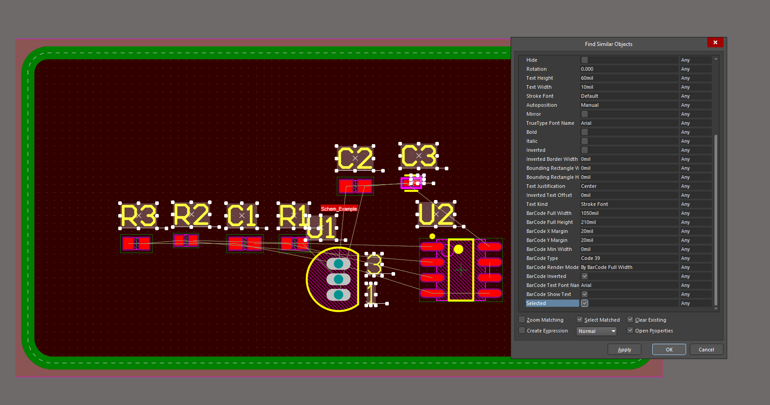

Now all designators are selected:

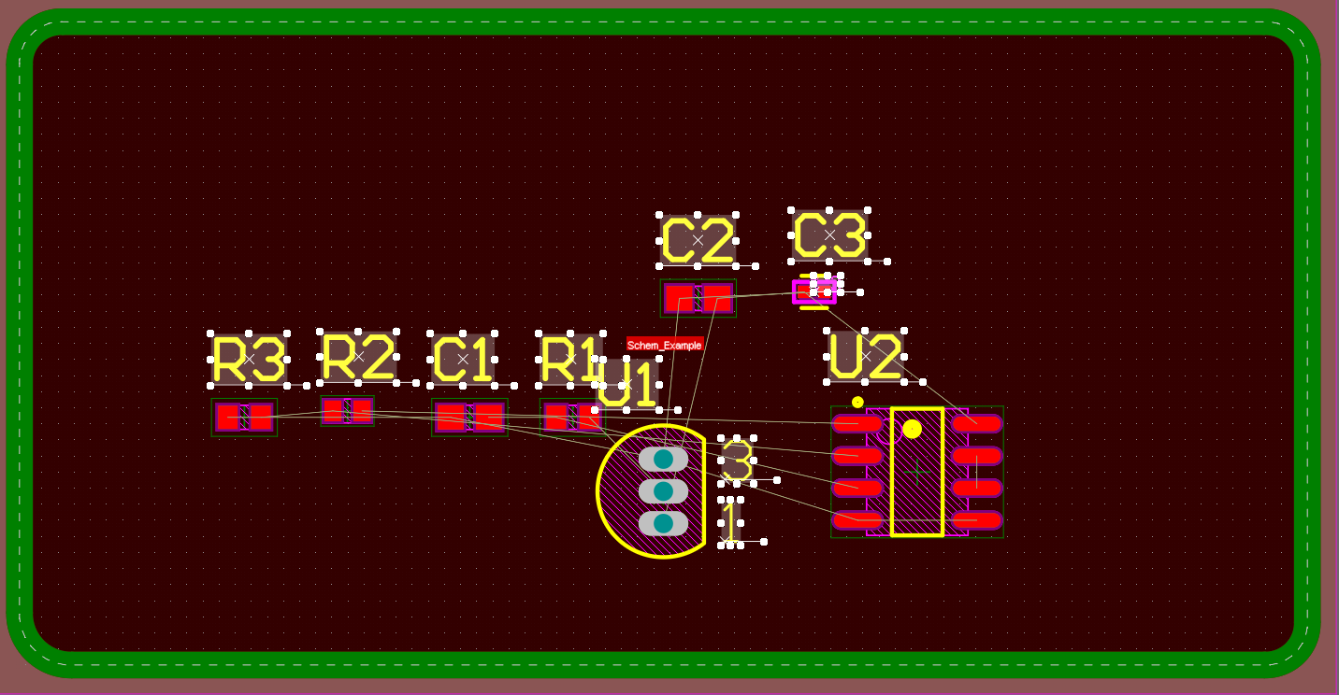

Look towards the right side of the screen, change “Text Height” & “Stroke Width”:

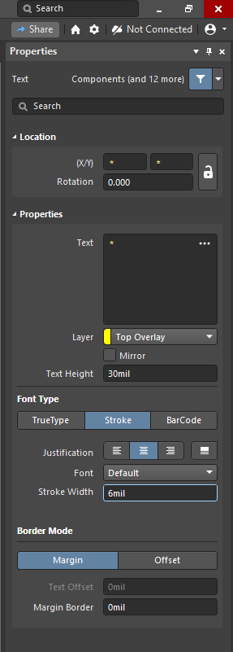

(I chose 30mil height and 6 mil width)

Now Designators are an appropriate size

Arrange Parts onto PCB that allows for connections (disregard power pins for now):

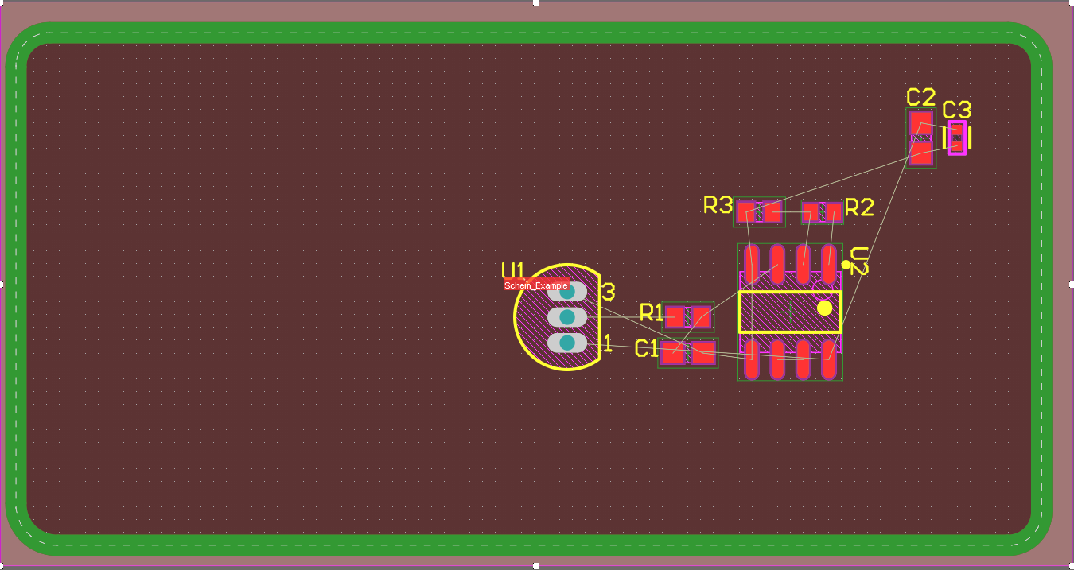

Note that lines appear to show you “net” connections

Place Tracks using “p” and then “t” keys:

Connect parts as they should be connected:

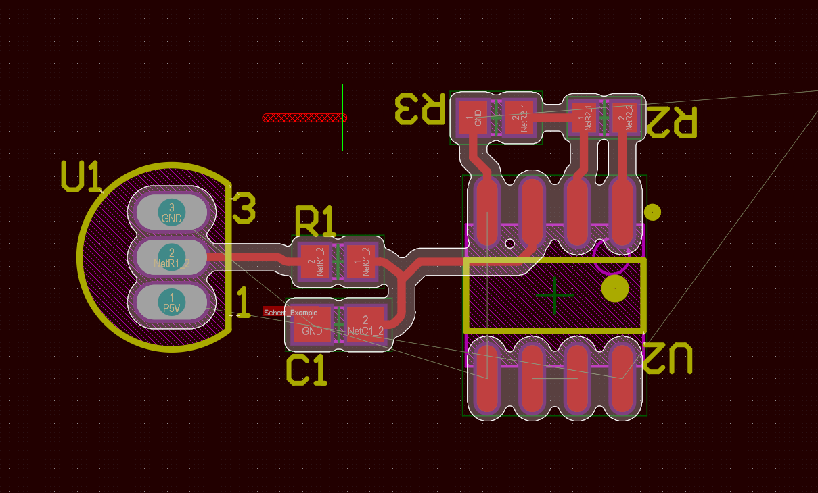

Add solder pads: hit “p” twice, and then hit TAB key:

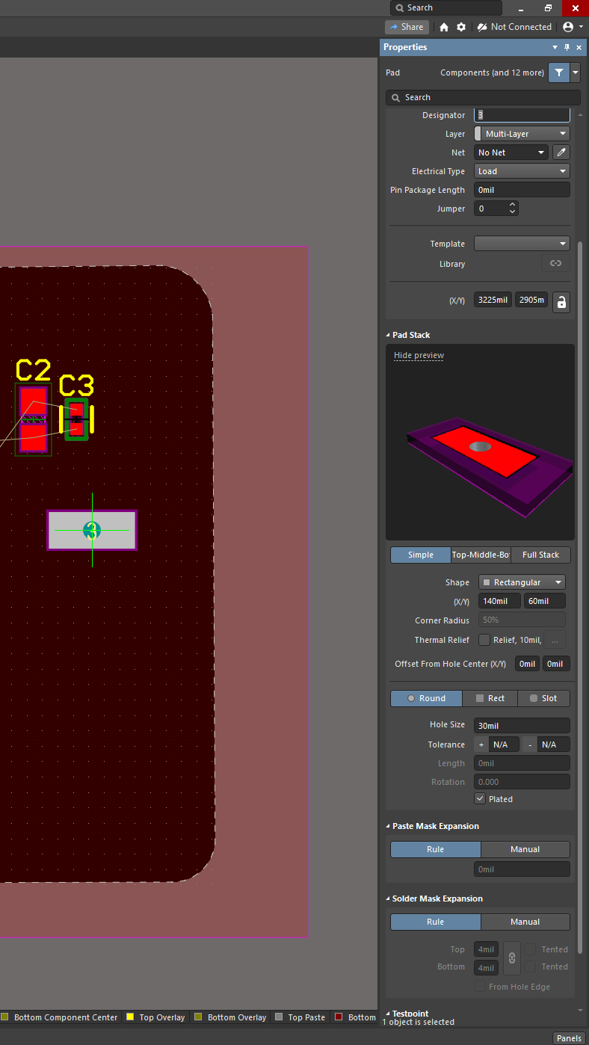

A solder pad will appear, adjust the Shape and then X/Y to make a rectangular like shape (this pad will be solder to a wire)

Then, Change hole size of pad to zero:

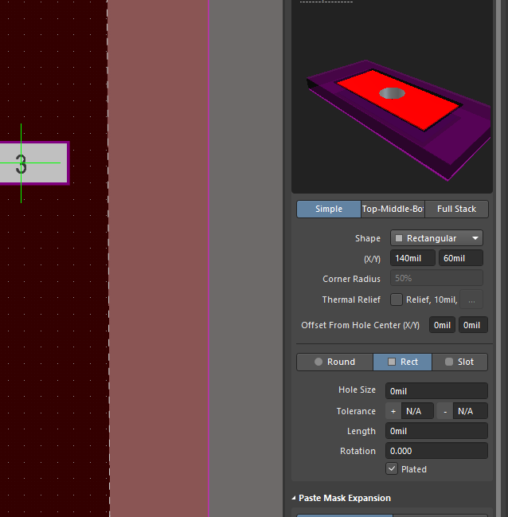

Place pads:

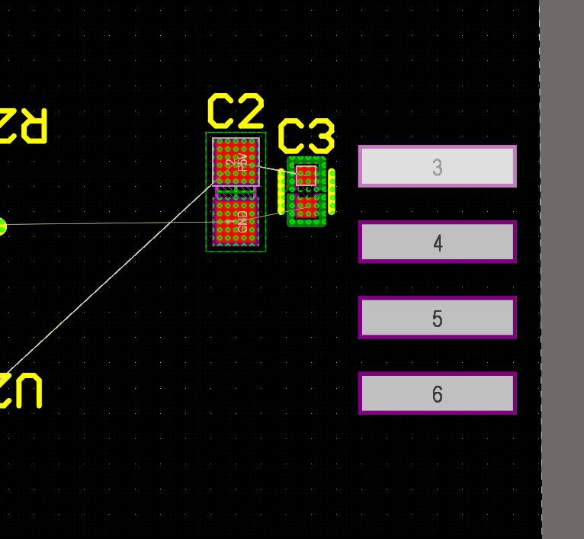

Assign nets to solder pads:

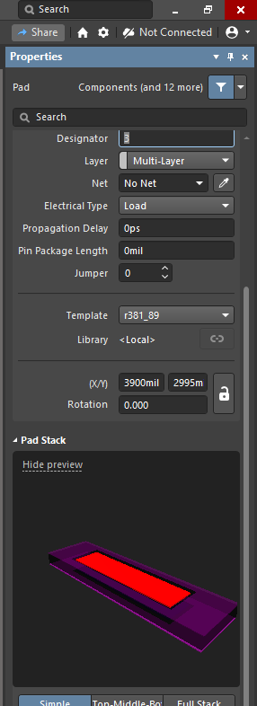

Netted Pads:

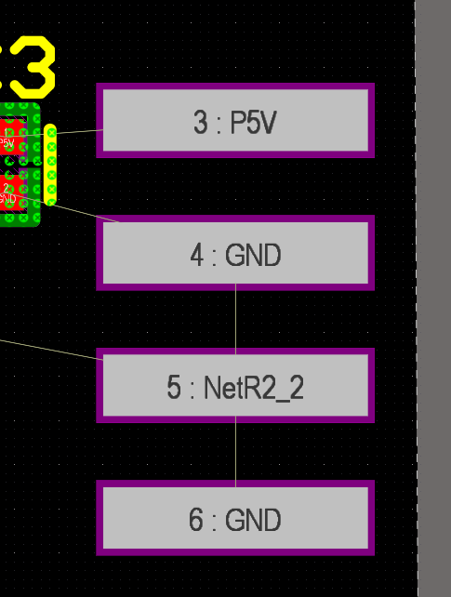

Make pads single layer:

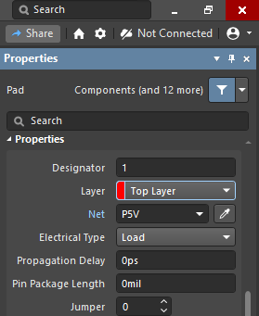

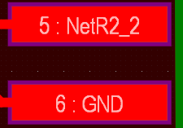

Polygon Pours type “p” and then “g” and then drag over objects: (SHIFT + SPACE to change curve)

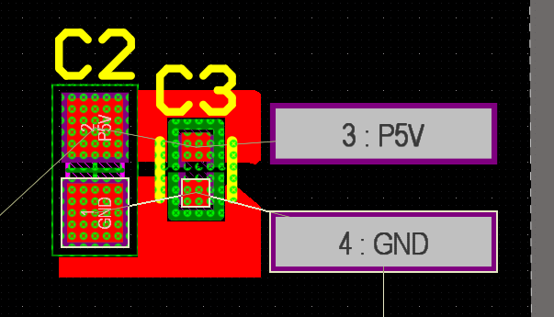

Assign poly pour nets to pads and then repour all polygon (hit “t” “g” “a”)

If pours come out weird:

Change pour settings to “Pour Over All Same Net Objects”

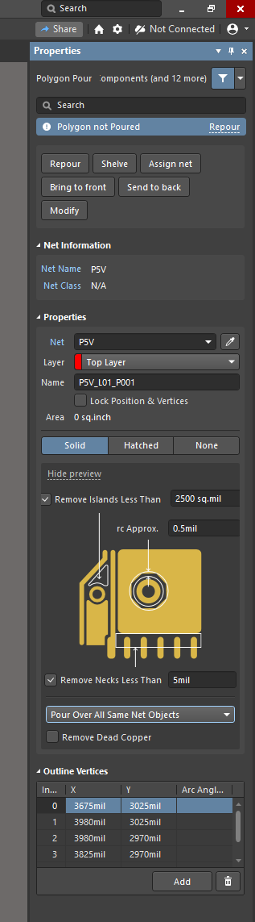

If still weird, perform the following:

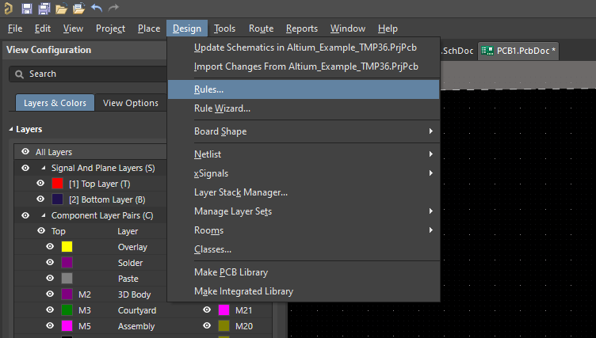

* Plane > Polygon Connect
  + Change Connect Style from Relief connect to direct connect:

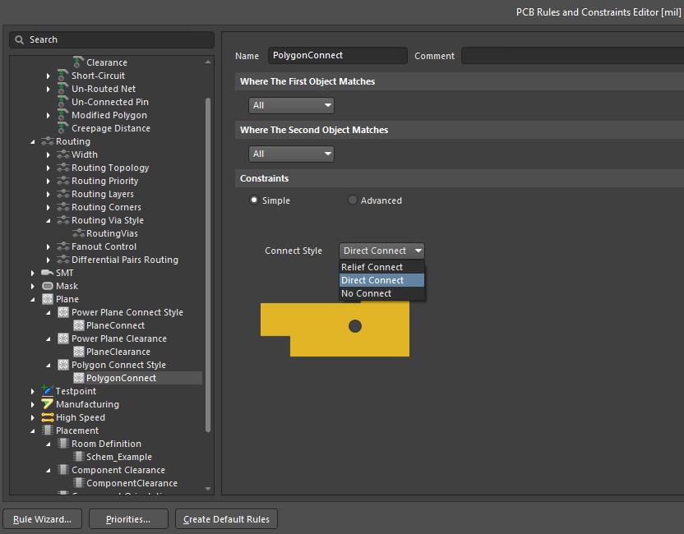

Hit Apply and then Okay

Repour using “t” “g” “a”:

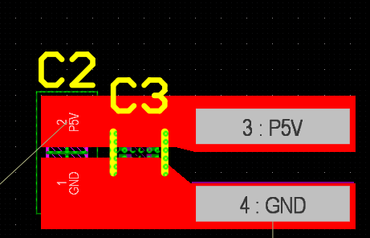

Now all tracks and resistors are placed (Time for Vias!!!!)

Before Vias, we must net layers of the board (we are connecting power to layers, 5V & GND)

Select the layer in the bottom that you wish to net, right click the board (anywhere with empty black space), hit Properties, and then choose the net you want:

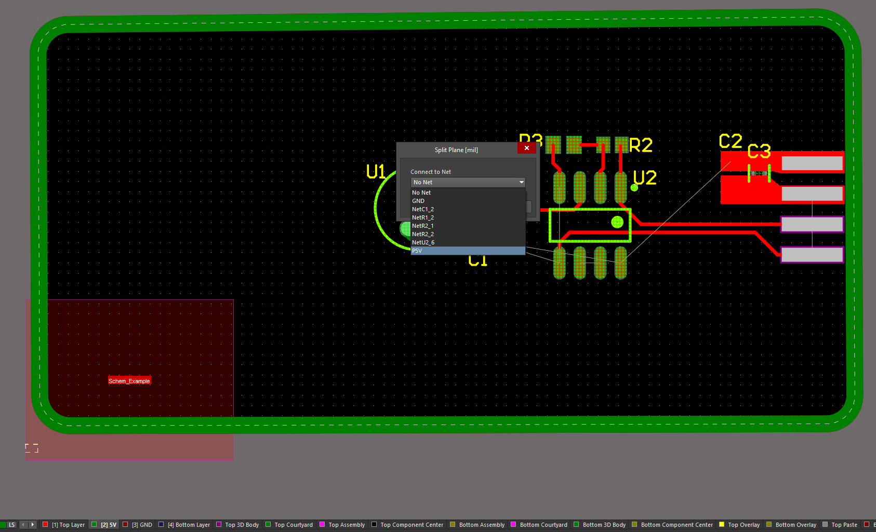

Repeat for any other layers

OSHPARK Via Requirements:

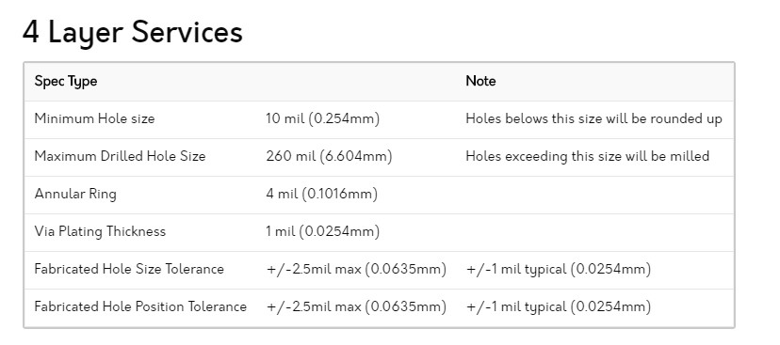

Settings in Altium (Design > Rules > Routing Via Style > Routing Vias: Adjust Settings:

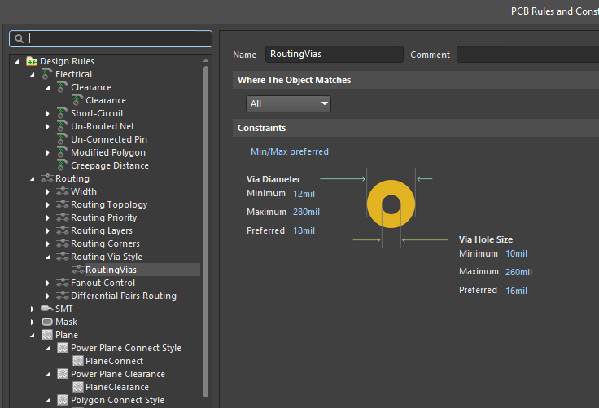

Placing Vias: Hit “p” “v” and then click:



Assign net to Via:

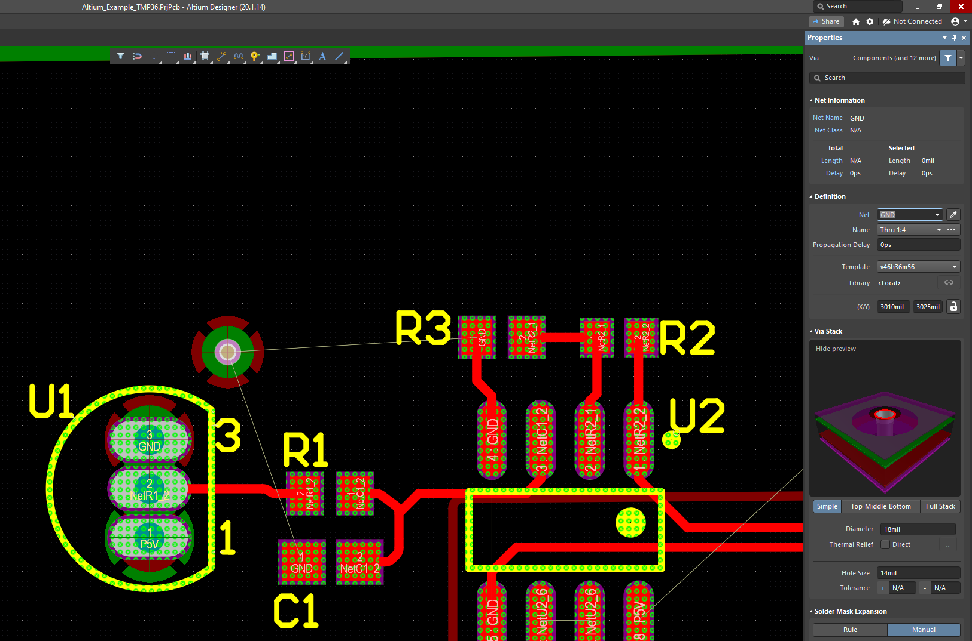

Connect to via using track:

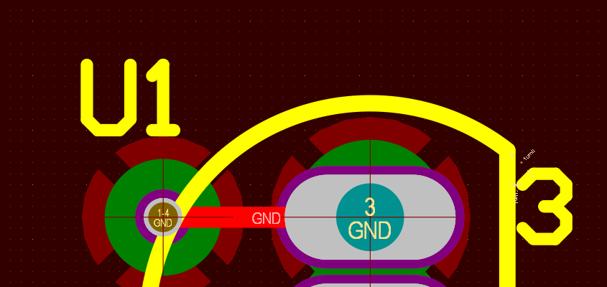

Place and connect all Vias:

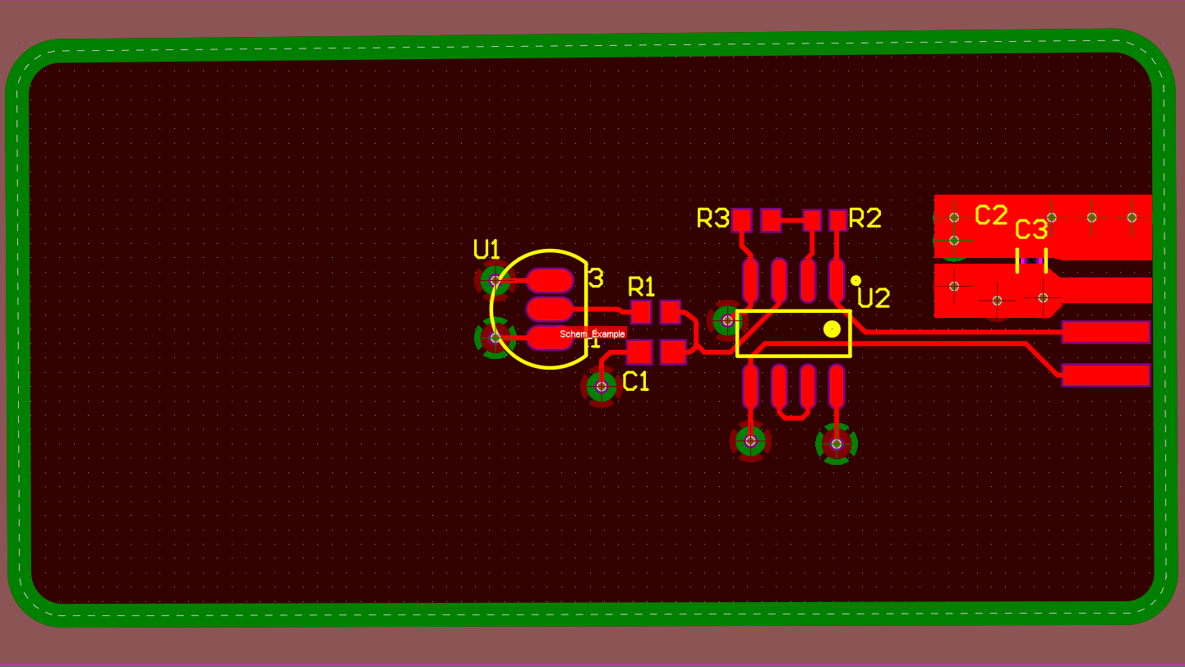

Board is Complete:

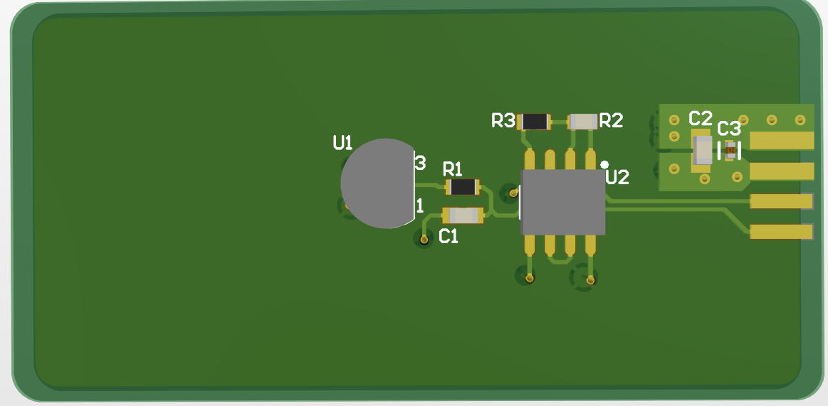

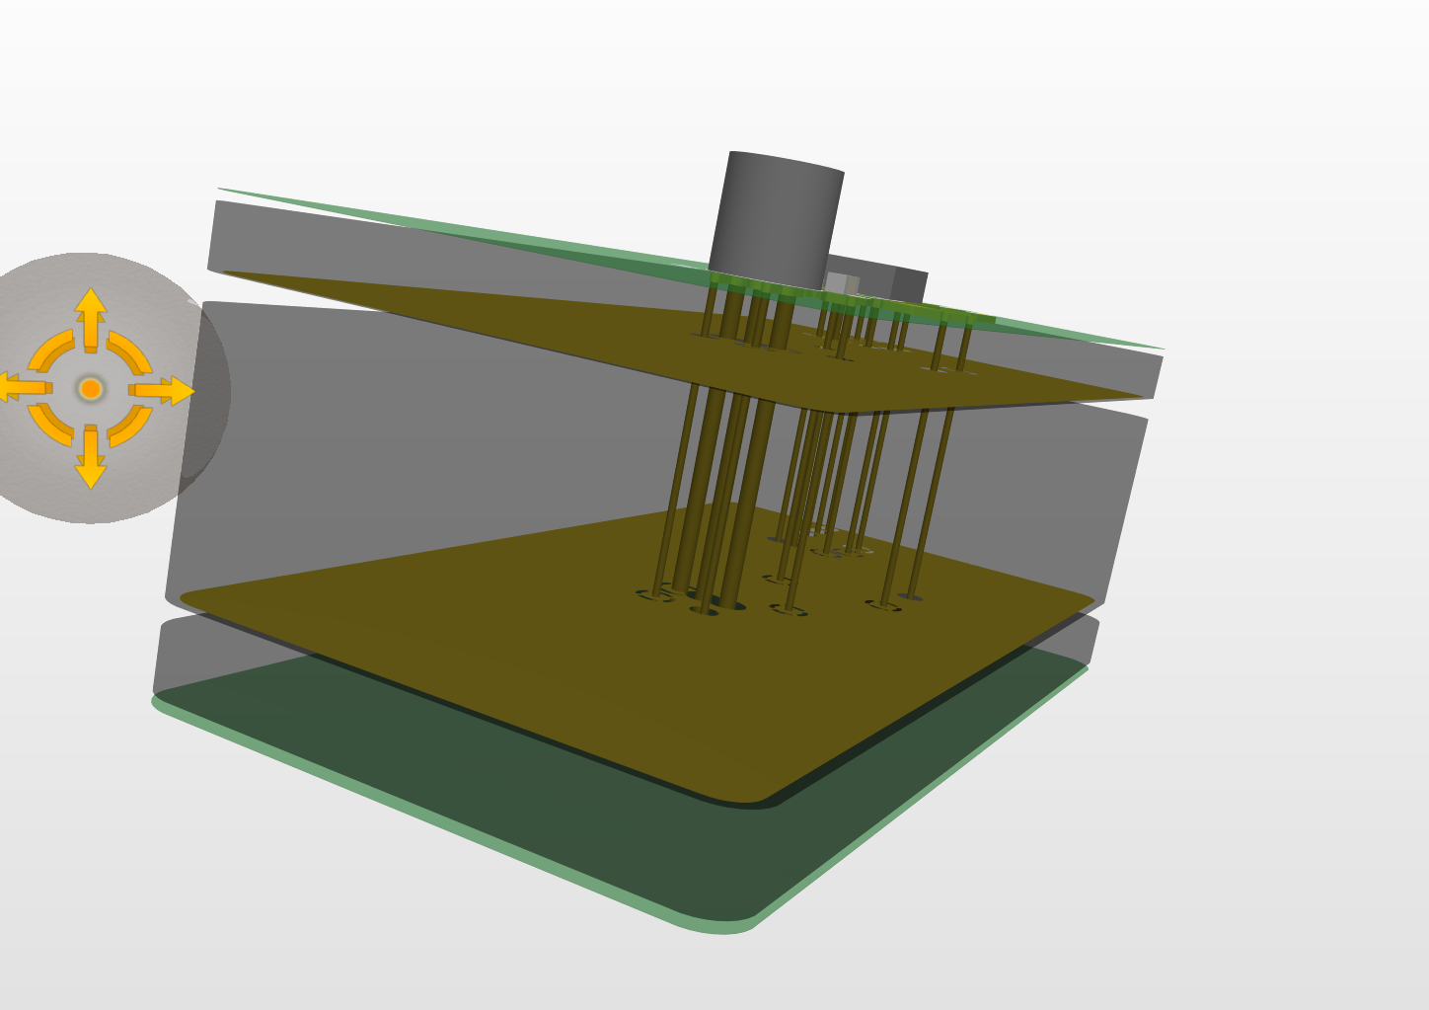

Bottom view:

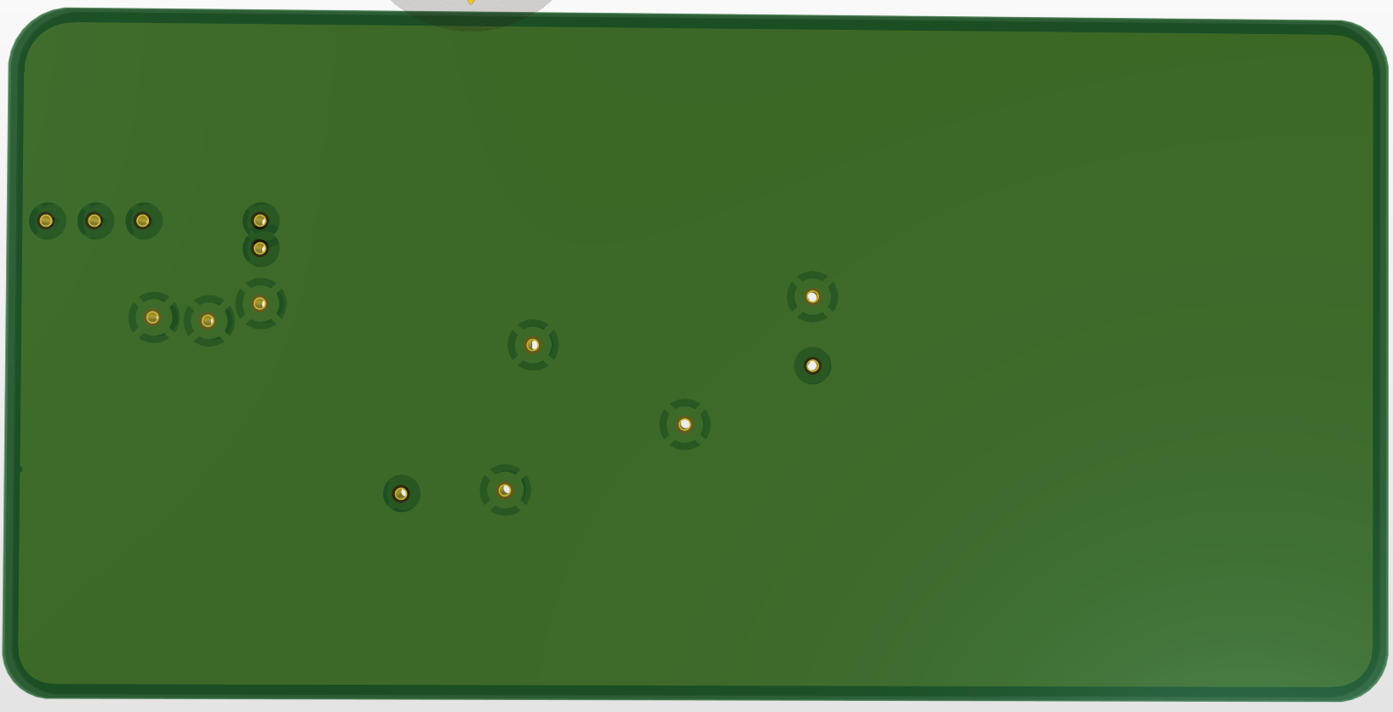

**DEFINE BOARD SHAPE:**

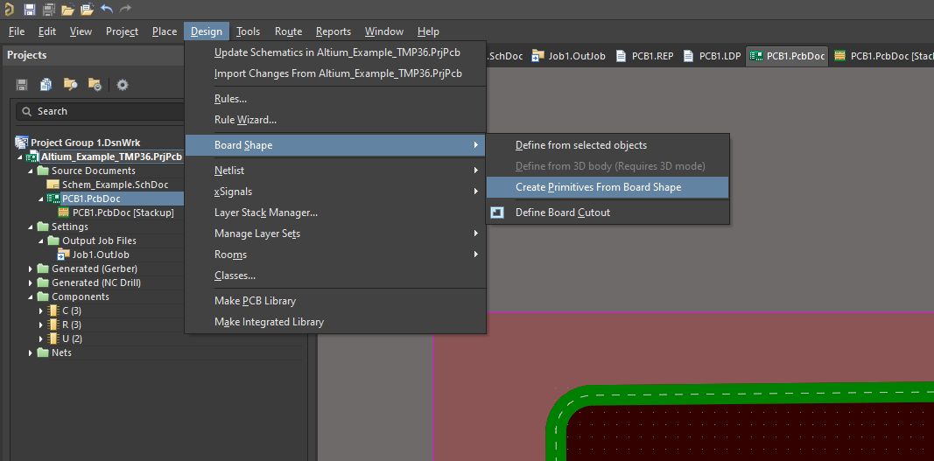

**KEEP EXACT SETTINGS AS THE FOLLOWING:**

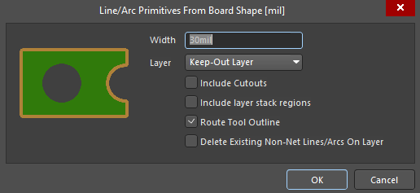

Output Job Guide:

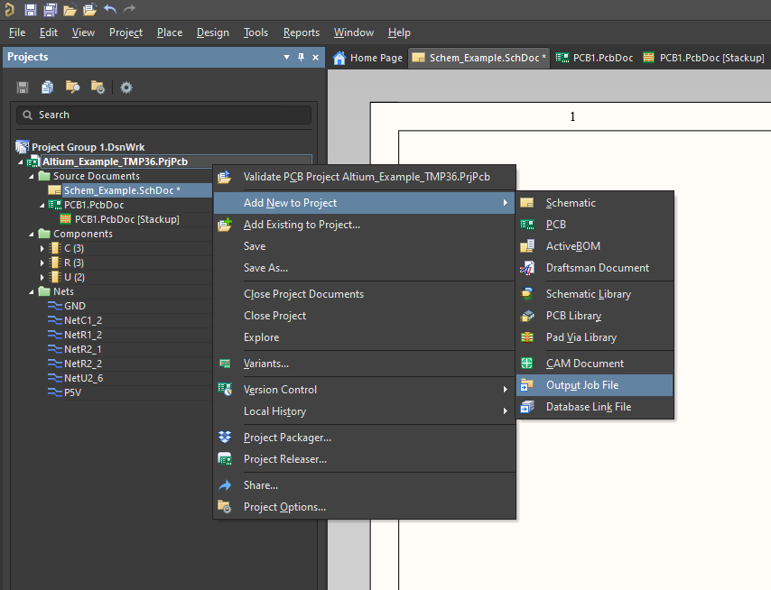

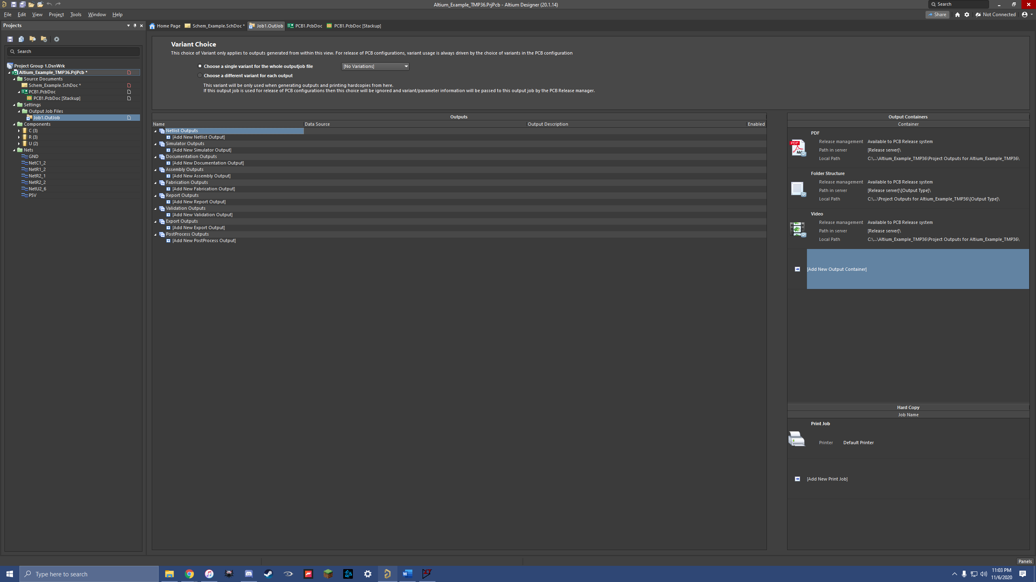

Fabrication files:

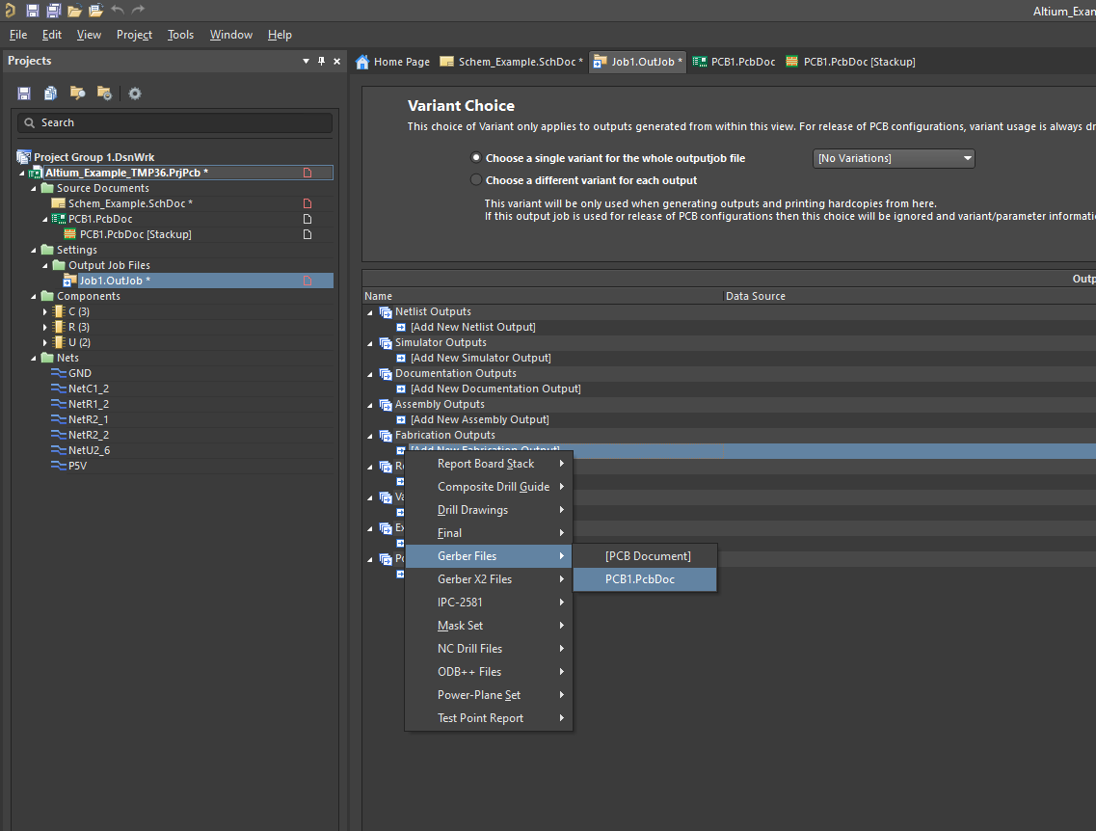

Double click “Gerber Files”

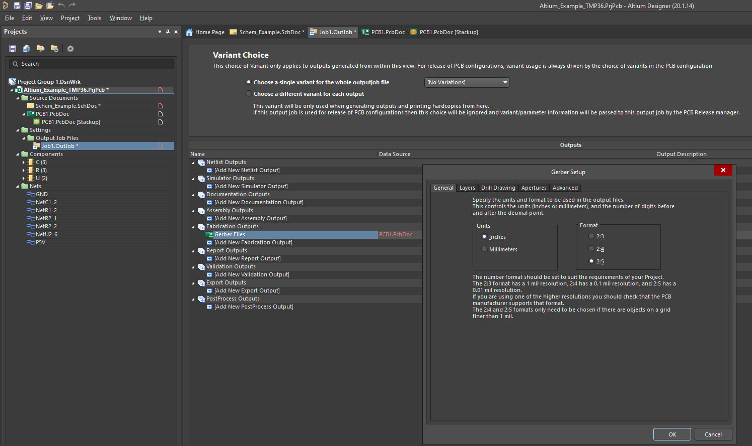

Set these settings up:

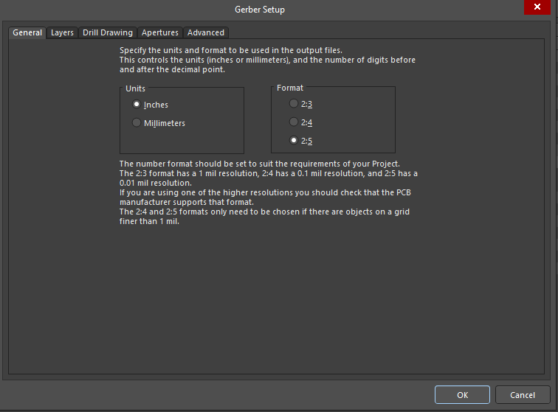

Under “Layers” Click the following:

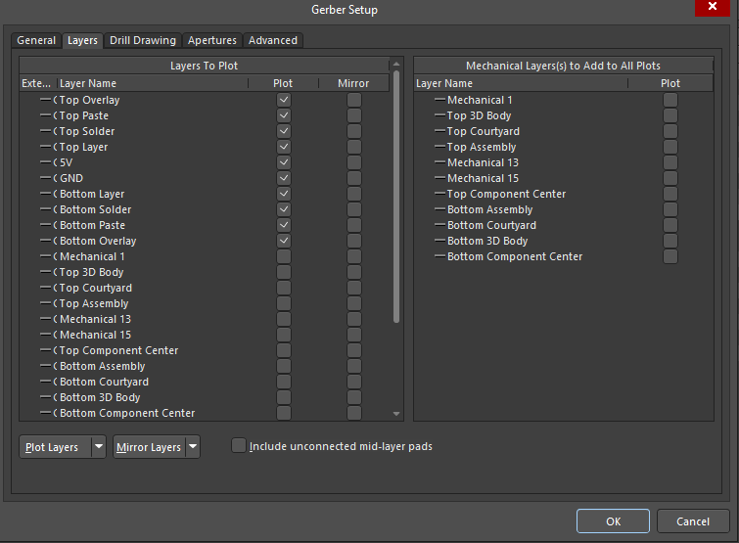

Under Advanced: (click use software Arcs)

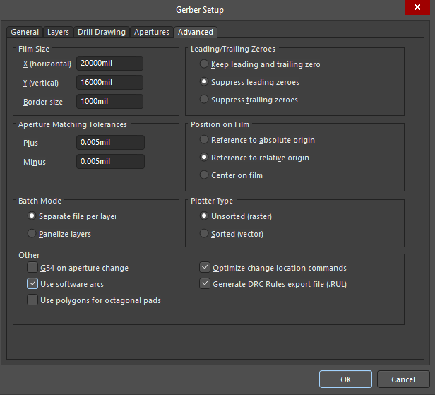

Clic

NC Drill Files:

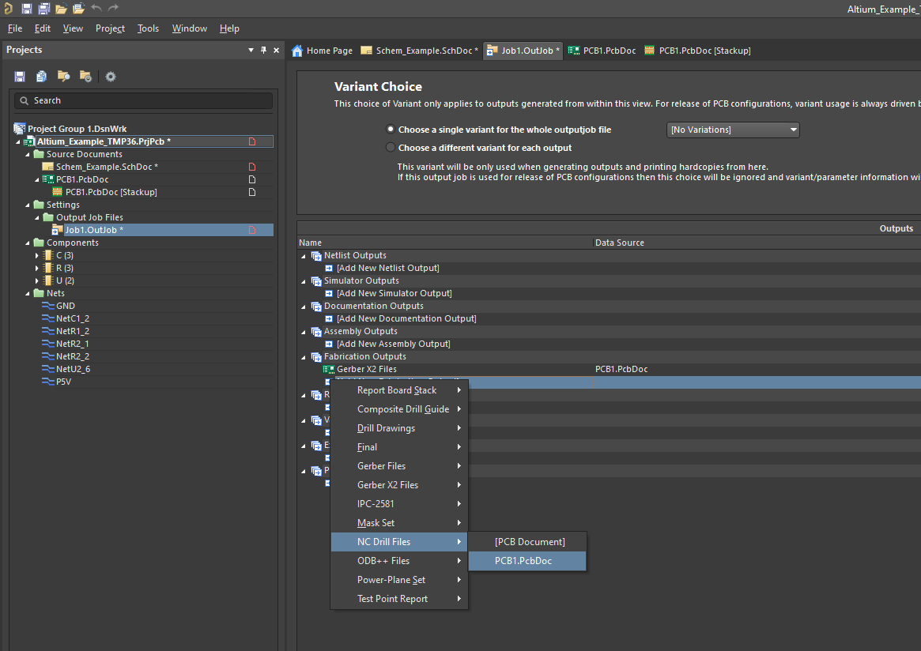

Double click NC Drils:

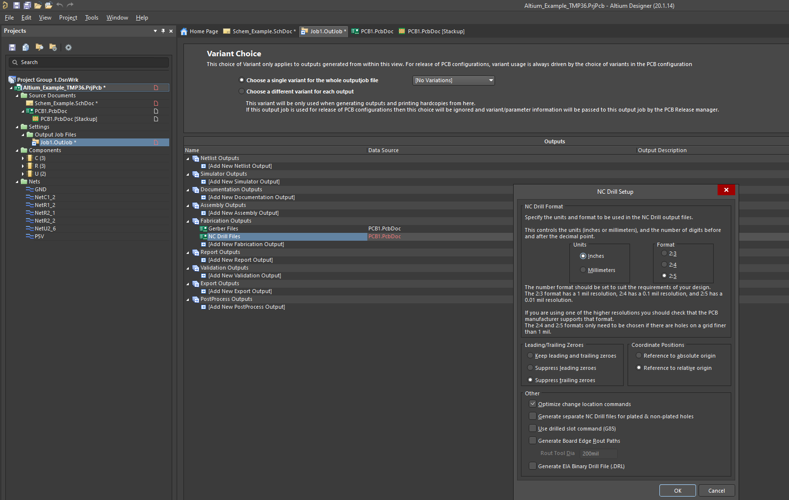

Change to these settings:

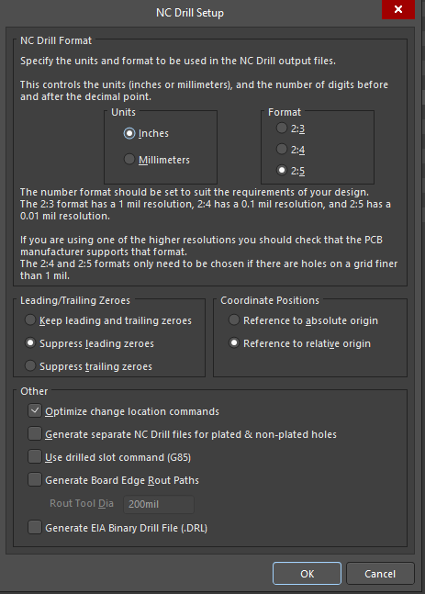

Hit 2 dots near “Folder Structure”

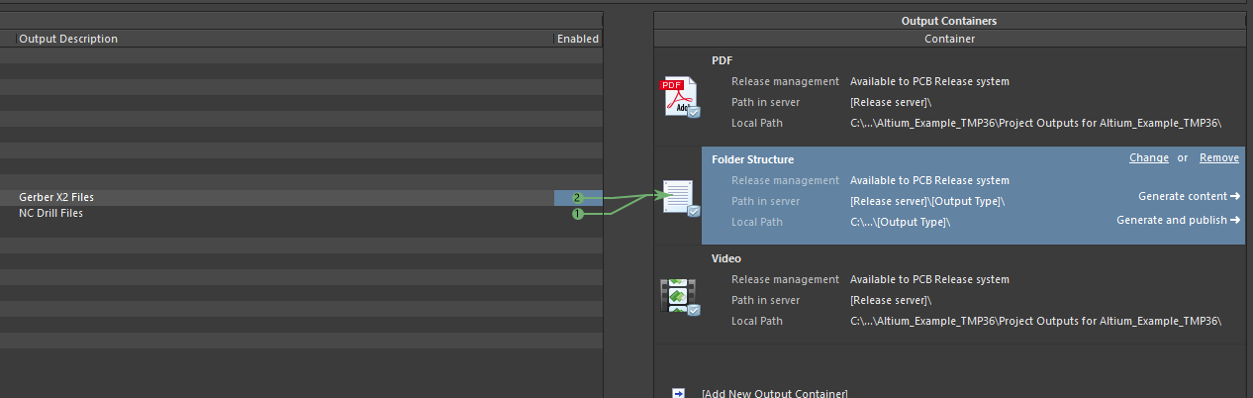

Click “Generate Content”:

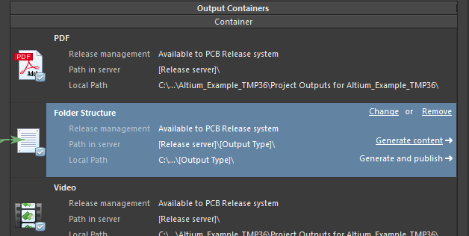

Go to project folder:

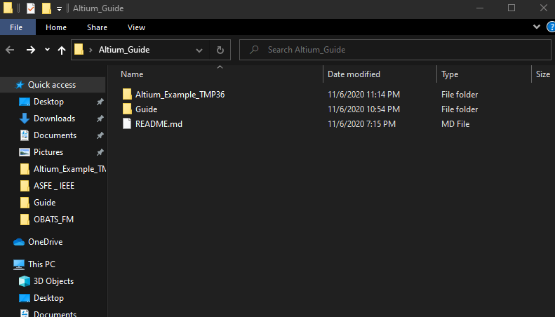

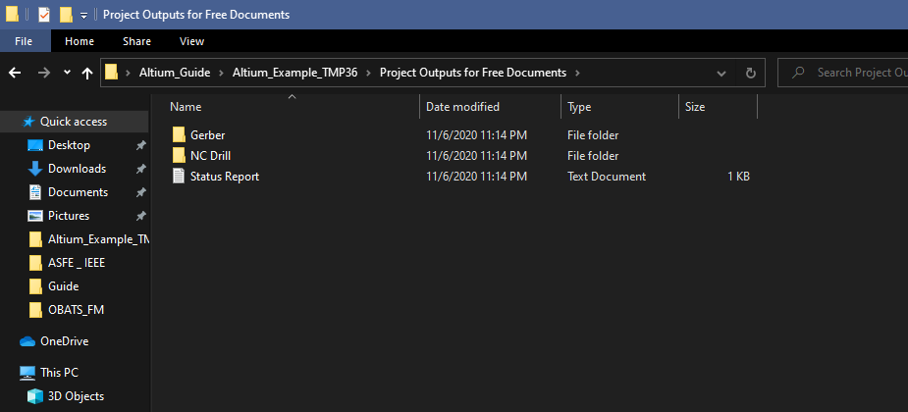

Cut the NC Drills folder and paste into Gerber folder:

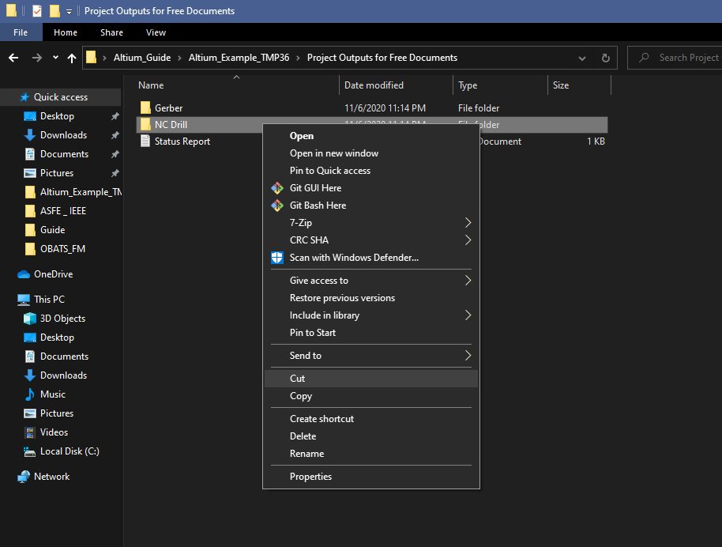

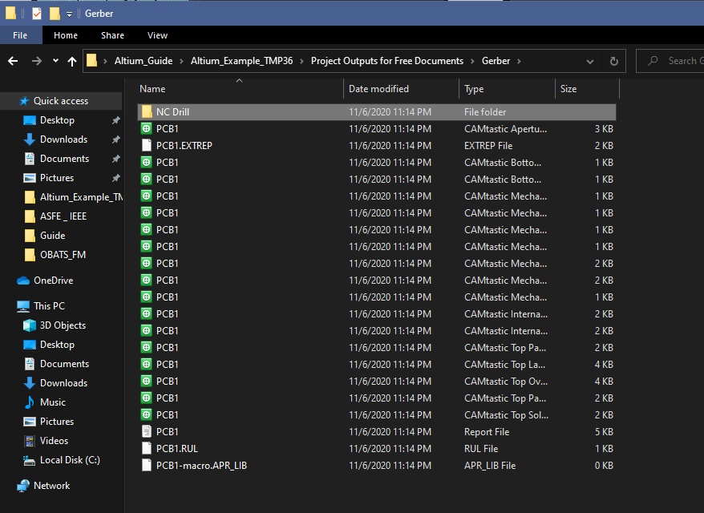

Compress the Gerber Folder:

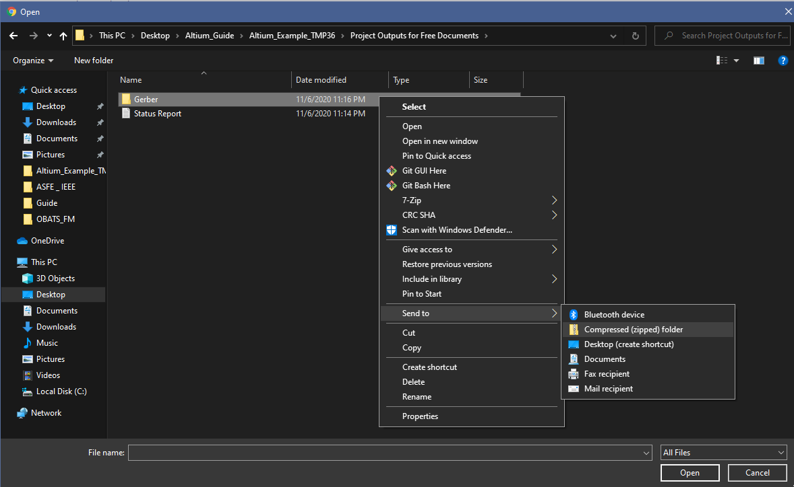

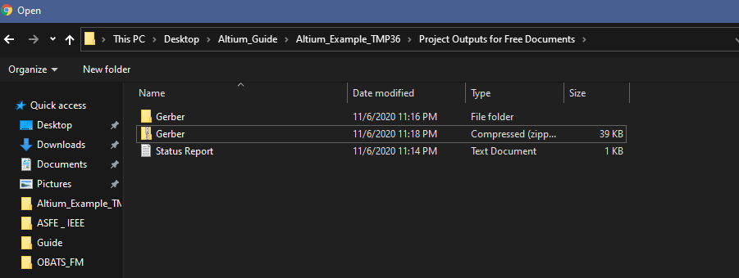

Upload zip folder to OSHPARK:

